

North America > Canada > British Columbia > Lower Mainland > Vancouver

Vancouver

For other places with the same name, see Vancouver (disambiguation).

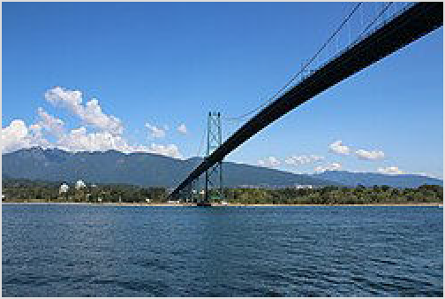Vancouver occupies an enviable spot in the world. Blessed with miles of coastline, lush vegetation and crowned by the North Shore Mountains, it's hard to be there and not stop at some point and be amazed by what you see.

But scratch beneath that setting and you find a cosmopolitan city of many faces. It is a mix of old and new, a stopping place for immigrants that have infused the city's neighbourhoods, festivals and food. On one hand, Greater Vancouver is the third largest metropolitan area in Canada, the second biggest

View of Lions Gate Bridge from the Stanley Park Seawall path.

destination for visitors to the country and the economic hub of British Columbia. A modern city of glass towers with a variety of festivals, cultures and attractions, it has also been host to world events like the 1986 World Exposition and the 2010 Winter Olympics. To others, it's Vansterdam, the laid-back socially progressive city with the laissez-faire attitude to marijuana.

With its Asian heritage and relative proximity to China and Japan, some see it as the gateway to Asia; often called Hongcouver due to the large number of immigrants and political refugees from Hong Kong living in the area. And with all that nature minutes from your door, Vancouver is a haven for outdoor enthusiasts. It's one of those rare places you could ski in the mountains, hit one of the many sandy beaches and play a round of golf all in the same day. Vancouver is one of the most culturally diverse and cosmopolitan cities in the world, with just under half its residents born outside Canada.

All of this makes it easy to be a local. Walk the Seawall. Spend a day in one of the parks. Indulge in food and treats from around the world at a neighbourhood restaurant. Or just grab a spot at the beach or on a patio and watch it all go by – Vancouver is, after all, one of the most beautiful spots in the world.

Districts

Vancouverites broadly split the City of Vancouver in three: the Westside, the Eastside (or East Van) and city centre. This split is simply geography: everything west of Ontario St is the Westside, everything east is East Vancouver and everything north of False Creek is the city

centre. Each of these areas have their own attractions and neighbourhoods, so time permitting, explore as many as you can. This list covers only the City of Vancouver. For the rest of Greater Vancouver, see Lower Mainland.

City Centre

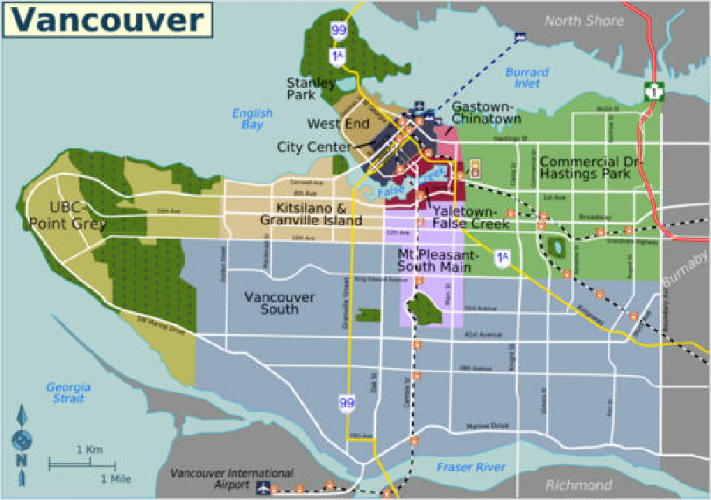City Centre (Central Business District)

City of Vancouver — switch to interactive map
The financial, shopping and entertainment centre of the city. It has many of Vancouver's most notable landmarks and easy connections to other parts of the city and the Lower Mainland. With its multitude of accommodation and restaurant options, it is the ideal, if pricey, place to base yourself for exploring the city.

Stanley Park and the West End
One of the most popular places to hang out in Vancouver, with its beaches, Stanley Park and lots of little shops and eateries.

Gastown-Chinatown
The original townsite of Vancouver. Gastown is a mix of kitsch, heritage and urban chic. Chinatown was historically one of the largest Chinatowns in North America.

Yaletown-False Creek
Reclaimed industrial land that is now modern trendy neighbourhoods with some fantastic views along False Creek. The district hosts Vancouver's major spectator sports and was home to the Athlete's Village from the 2010 Winter Olympics and the site of the World Exposition in 1986 (Expo 86).

Outside the city centre

Kitsilano & Granville Island
The very popular Kitsilano Beach, art studios, the famous Granville Island Public Market and fantastic urban style shopping - particularly 4th Avenue, 10th Avenue and Broadway where chain stores mix with unique independent shops.

UBC-Point Grey
The University of British Columbia campus has a number of attractions, including two sets of gardens and the acclaimed Museum of Anthropology. Nearby is Pacific Spirit Park, and further east in Point Grey, are three large beaches, Jericho Beach, Locarno

Beach and Spanish Banks. The UBC campus is also home to the popular clothing optional beach, Wreck Beach.

Mt Pleasant-South Main
Main Street is an up and coming artsy part of the city filled with unique shops, eccentric cafes, hip bars, and a number of breweries. Nearby is Queen Elizabeth Park, which is the highest point in Vancouver and has some excellent free gardens.

Commercial Drive-Hastings Park
A mostly residential area of the city. Commercial Drive has many ethnic bars and restaurants, as well as an arts scene, such as Art Works BC Gallery, Slive of Life and many others.

Vancouver South
A mostly residential area that includes the Kerrisdale, Dunbar, Oakridge, Marpole, Shaughnessy and Killarney neighbourhoods.

Understand

While Vancouver is a comparatively young city, founded in 1867, its history begins long before. The Coast Salish indigenous peoples (First Nations) have lived in the area for at least 6,000 years. The present city's namesake Captain George Vancouver sailed through the First Narrows on 13 June 1792, naming Burrard Inlet after his friend Sir Harry Burrard. The first settlement on the downtown peninsula was Granville, on the spot of today's Gastown. In 1867, the year of Canada's confederation, a saloon was built on this site and gave birth to a small shantytown of bars and stores, adjacent to the original mill, on the south shore of what is now the city's harbour. A seemingly endless supply of high-quality lumber was logged and sold through the ports of Gastown and Moodyville, across the inlet. Some of the trees were gigantic beams which were shipped to China to construct Beijing's Imperial Palace. One account maintains that the world's windjammer fleets could not have been built without the trees of Burrard Inlet.

Vancouver's first City Hall was little more than a hand-painted sign nailed to a wooden tent post. The arrival of the transcontinental railway, a few years later, spurred growth even more, and by 1892 the area had over 20,000 residents. 18 years later, this figure was over 100,000.

Factor in constant growth every year since (many in the double digits), and Greater Vancouver today is Canada's largest metropolitan area west of Toronto by far, with more than 2,600,000 residents, more than half of British Columbia's population as a whole. It is also the fastest growing part of Canada. During the 1980s and 1990s, Vancouver received a large number of immigrants from Hong Kong fleeing the impending handover to China. Greater Vancouver is today one of the most ethnically diverse metropolitan areas in the world, home to the second largest Chinese population in North America after the San Francisco Bay Area, and with about half its population being born outside Canada. It is also home to a large and influential Sikh community, and one of the main centres of the Khalistan movement that advocates for the carving out of an independent Sikh nation from India.

For many, Vancouver truly "arrived" in 1986, when the city hosted the Expo 86 World's Fair. Media attention from around the world was consistently positive, though many saw the resulting gentrification of poorer areas as being harmful to Vancouver's lower-class citizens, as many residents of the Downtown Eastside were evicted from their homes (https://grayly.ca/city/e04c7 733-5987-42f9-8a6b-2f4bdb3d9910/bc-vancouver). Vancouver also hosted the 2010 Winter Olympics, which was largely seen as another success, though it brought some similar criticisms.

Vancouver is perhaps best known for its scenic beauty, and the opportunities afforded by its natural environment. Vancouver is one of those rare places where you could theoretically ski in the mountains, windsurf in the ocean, and play a round of golf all in the same day. Surrounded by water on three sides, and crowned by the North Shore mountains, Vancouver is a great destination, and a great starting point for discovering the area's many outdoor activities.

Vancouver is a major sea port on the Pacific Ocean, and a base for many Alaska cruise ships in the summer. It has the same name as another city in the region, Vancouver, Washington (United States).

Vancouver is believed to be the inspiration for the fictional setting of Adventure Bay, in the animated children's television series PAW Patrol.

Vancouver's residents enjoy a high standard of living, and the city is consistently ranked among the most livable on Earth.

Climate
Vancouver (West End/Vancouver Harbour/Stanley Park)
Climate chart (explanation)
J F M A M J J A S O N D
23 23
18
20
19
7
8
11
14
14
10
13
15
15
12
7
7
10
9
3
3
5
5
3
237 117 163 118 73 66 44 49 71 157 245 200
Average max. and min. temperatures in °C Precipitation+Snow totals in mm
Imperial conversion
[Expand]
Depending on who you talk to, or perhaps, when, Vancouver's climate is either much maligned or envied. Late fall and winter are typically damp with clouds smothering the sky like a wet grey blanket (there's a reason Vancouver is sometimes referred to as the "Wet Coast"). But there are benefits to all that rain: it's usually not snowing (unlike most of the rest of Canada) and it leads to a gorgeous display of colour with the start of spring in early March. And that's where Vancouver really shines – the spring and summer. Springs can still be wet, but it gets warmer and the shrubs, blossom trees and flowers put on a pretty show. Summer days are long and usually sunny with little humidity. Summer daylight lasts from 5:15AM to as late as 9:15PM in late June.

Summer temperatures from mid-June to early- Sept are mostly comfortable. Temperatures peak in late July and early August with an average
daytime highs around 23 °C (73 °F) and overnight lows around 15 °C (59 °F). Some particularly hot days can see temperatures climb upwards to 26 °C (79 °F) and not go below 17 °C (63 °F) at night. Daytime summer highs increase the further east you go, with eastern areas of the city having average daytime highs around 25.6 °C (78.1 °F), climbing around to or even exceeding 31 °C (88 °F) on exceptionally hot days.
Spring and fall are cooler and wetter, so packing a mix of cool and warm weather clothing is recommended. If visiting Vancouver between November and March, be prepared for wet weather and cool temperatures. Daytime highs are typically around 5-8°C (40-50°F) while overnight lows will get close to 0°C (32°F) and sometimes colder. December and January are the coldest months, with the most rain and a chance of snow. While Vancouver's winters are not as harsh as

those in other major Canadian cities, the city does get a few days of snow in the winter months every year. Sunrises in winter are after 8AM, with darkness setting in prior to 4:15PM in December.

Visitor information
Destination Vancouver (https://www.destinationvancouver.com) no longer has a traditional visitor centre, but keeps a free information telephone line, at +1 604-683-2000. As of June 2025, it operates between 08:00 and 16:00. There is still a small mobile booth which offers maps, brochures and other information for visitors, which as of June 2025 is located at Canada Place, the East building of Vancouver's Convention Centre, next to the convention centre's information kiosk (with a blue tablecloth).

Get in

By plane

Vancouver International Airport
Main article: Vancouver International Airport
- Vancouver International Airport (https://www.yvr.ca) (YVR ^{IATA}), 3211 Grant McConachie Way, Richmond (Sea Island in Richmond), ☏ +1 604-207-7077, customercallcentre@yvr.ca (mailto:customercallcentre@yvr.ca). The Domestic and International Terminal is the main terminal that most travellers will use, while the South Terminal has prop, small jet, and seaplane service to local communities in British Columbia and Yukon.
YVR is the second busiest airport in Canada, with frequent flights from cities in British Columbia, the rest of Canada, other North American countries, Asia, and Europe. It is also the only Canadian airport to have direct flights to Australia and New Zealand because of its westerly location.

TransLink's (https://www.translink.ca/) SkyTrain (Canada Line) provides direct service to downtown Vancouver in 25 minutes. The fare from YVR to Vancouver is $9.85 (July 2025), which includes the two- zone base fare of $4.85 plus a $5 surcharge (the "YVR AddFare (https://www.translink.ca/transit-fares/transfe rring-and-addfare)") incurred only for departures from the airport. Bus N10 runs overnight to Vancouver when the Skytrain service is closed. Route C92 connects the South Terminal with Bridgeport station on the Canada Line during limited daytime hours.

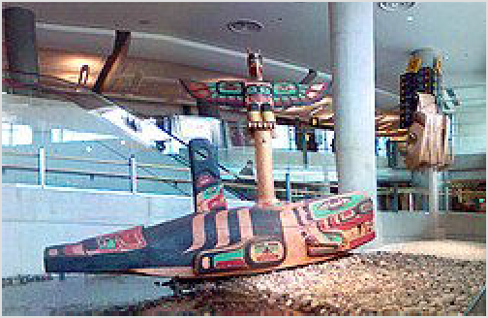Artwork inside Vancouver International Airport

The typical travel time from the airport to downtown by taxi is 20-30 minutes. Fares for a taxi ride from the airport to Vancouver or Richmond are fixed and vary depending on the zone of the destination. The zone map and fixed rates are posted at YVR Taxis (https://www.yvr.ca/en/pass engers/transportation/taxis). Metered fares apply for all trips going to the airport, and for trips from outside the zones. All taxis that serve the airport are required to accept credit cards.

Seaplane
There are floatplane facilities about 300 metres south of YVR's South Terminal and in downtown Vancouver at:

- Vancouver Harbour Flight Centre (https://www.vhfc.ca/) (CXH ^{IATA}), 1055 Canada Place (Downtown Vancouver), ☏ +1 604-647-7570. VHFC Terminal opens daily at 7:00 AM. Operating hours change seasonally. (updated Jan 2026 | )
These floatplane facilities offer frequent flights to downtown Vancouver and/or YVR. Flight to downtown Vancouver from Comox (50 minutes, summer), Nanaimo harbour (20 minutes), Powell River (40 minutes), Tofino (1 hours, summer), Victoria's Inner Harbour (35 minutes), Whistler (45 minutes, summer) the scenic Southern Gulf Islands and other local destinations. Some float plane operators also offer spectacular tours of the central city and nearby attractions starting at about $80-100 per person. A great way to see a panoramic view of downtown. A quick search of Google will bring up websites for most of these float plane operators. See Vancouver International Airport for seaplane flights that land at that airport.
Seaplane airlines operating to downtown Vancouver:

Harbour Air (https://www.harbourair.com/), ☏ +1-604-274-1277, toll-free: +1-800-665- 0212. Operates seaplane flights mostly to coastal communities in southwestern British Columbia. (updated Apr 2022 | )
Seair Seaplanes (https://www.seairseaplanes.com/), ☏ +1-604-273-8900, toll-free: +1- 800-447-3247. Operates seaplane flights to coastal communities in southwestern British Columbia. (updated Apr 2022 | )

Helicopter
There are heliport facilities at YVR's South Terminal, though most flights operate to:

- Helijet (https://helijet.com/), 455 Waterfront Rd W (near Waterfront Station in downtown Vancouver), toll-free: +1-800-665-4354. Operates helicopter service from the downtown heliport next to Waterfront Station, providing quick and convenient connections to Victoria and Vancouver International Airport (YVR) south terminal.

Other nearby airports

- Abbotsford International Airport (YXX ^{IATA}), 30440 Liberator Ave, Abbotsford (Abbotsford). Around about 60 km (37 mi) east of Vancouver in Abbotsford is Vancouver's alternate airport. It handles mostly domestic and low-cost carrier flights and, with an arranged ride, you can be in and out of this airport in under 10 min (with no checked in baggage). The best way to reach Vancouver from Abbotsford Airport is by car: take the Trans-Canada Highway (Hwy 1) west. The drive will take 45–90 minutes, depending on traffic. There is no public transit link to this airport, but two intercity bus operators have stops at this airport and Vancouver's Pacific Central Station (see "By bus"). Car rentals are available at the airport.
- Seattle-Tacoma International Airport (SEA ^{IATA}), 17801 International Blvd, Seattle, WA (between Seattle and Tacoma). Flying in and out of Seattle, particularly for US destinations, and then using the bus, train, or car rental for travel to and from Vancouver can be a considerably less expensive option than buying a direct flight to the airport of Vancouver or Abbotsford. If required for your nationality, you will need a U.S. visa, and this could take some time to procure. For budget travellers, you may wish to consider checking flights to and from here. See "By bus" and "By train" for intercity travel options to Seattle. One bus operator provides direct access from the airport to Vancouver. Otherwise, travellers can take

Link rail rapid transit between the airport and near Seattle's downtown, where multiple bus options and a train option to Vancouver are available.
- Bellingham International Airport (BLI ^{IATA}), 4255 Mitchell Way, Bellingham, Washington (Bellingham). [1] About an hour from Vancouver (plus border time), and serves mainly as a launching point for budget-minded Canadian travellers vacationing in the U.S.: excellent service from Hawaii and Las Vegas, but few other useful connections. Also offers connecting service through Seattle-Tacoma International Airport. Shuttle buses to Vancouver run for $39 round trip. See "By bus" and "By train" for intercity travel options to Bellingham. One bus operator provides direct access from the airport to Vancouver. Otherwise, travellers can catch a bus (Monday to Saturday) or taxi between the airport and the other bus option and a train option to Vancouver.

By car
See also: Lower Mainland § By car
The main highway into Vancouver from the east is Highway 1 (Trans-Canada Highway). This road skirts the eastern edge of Vancouver, so if you want to get into the city, you will need to exit off it at Grandview Highway (exit 28A), 1st Avenue (exit 27) or Hastings Street (exit 26). Most major highways from interior British Columbia converge at Hope, 143 km (89 mi) east of Vancouver, then following the Trans-Canada Highway west into Vancouver.

From the U.S./Canada border south of the city, Highway 99, which links up with U.S. Interstate 5, runs north to Vancouver. The freeway ends after the Oak Street Bridge, turning into Oak Street heading north. Drivers with a downtown destination will need to get onto Granville Street (parallel to Oak St to the west), or Cambie Street (parallel to the east), in order to get on the Granville Street or Cambie Street bridges which cross False Creek into the downtown peninsula.

If you are coming from the North Shore or other points further north, the only way into Vancouver is by bridge. Your options are the Lions Gate Bridge (Hwy 99) which brings you into Stanley Park and Vancouver's West End or the Second Narrows Bridge/Ironworkers Memorial Bridge (Hwy 1) which brings you into the neighbourhoods of East Van.

By bus
Many bus services reach the Vancouver area, most of which terminate at Pacific Central Station (see "By train" below for the location and directions). A number of bus services also have additional pick-up and drop-off stops at hotels in downtown Vancouver, Richmond, Surrey, White Rock and in a number of places in the surrounding areas as well as from the airport. Not all bus lines serve the Pacific Central Station either. Buses cross the U.S./Canada border at an alternate crossing point (for trucks and buses) 5 mi/8 km east of the Peace Arch Park (BC Hwy 99/I-5) along BC Hwy 15/WA Hwy 543. Below are examples of bus lines with scheduled routes that reach the Vancouver area from various places nearby and afar in Canada and the United States:

BC Ferries Connector (https://bcfconnector.com/) (Wilson's Transportation Group) (Stops at Pacific Central Station), ☏ +1 250 475-3235. Connects Vancouver to Victoria via Tsawwassen-Swartz Bay ferry. Trip time to Vancouver from Victoria is 4 hours. (updated Apr
2022 | )
BC Transit (Central Fraser Valley Transit System) (https://www.bctransit.com/central-fr aser-valley/home) (Stops at Lougheed Town Centre station on SkyTrain's Expo Line and

Millennium Line), ☏ +1-604-854-3232. Offers a route between Burnaby and Chilliwack with stops in Langley and Abbotsford. Trip time to Burnaby from Chilliwack is 90 minutes and from Abbotsford is 52 minutes. (updated Mar 2022 | )
Cantrail (https://www.cantrail.com) (Amtrak Thruway) (Stops at Pacific Central Station), ☏
+1 604-294-5541, toll-free: +1-877-940-5561. Operates express buses between the Seattle King St Station (Amtrak) and Vancouver. They also make an additional scheduled stop at the Sandman Signature Hotel (10251 St Edwards in Richmond) to pick-up on the southbound trip and drop off only going northbound. Travel time to Vancouver from Seattle is 3.5 to 4 hours. To pay in US dollars or Amtrak rewards points, book on the Amtrak website. $40 for one-way, $75 round trip; discounts for students, military, seniors & children ages 4-11. (updated Mar 2022 | )
Ebus (https://myebus.ca) (Stops at Pacific Central Station), toll-free: +1 877-769-3287. Travels daily from Calgary, Kamloops, and Kelowna (via Salmon Arm), with stops in Merritt, Hope, Chilliwack, Abbotsford, and Surrey. Travel times to Vancouver from Kamloops is 4.5-
4.75 hours, from Kelowna is 5.5 hours, from Hope is 2.5 hours, and from Abbotsford is 1.25 hours. Same day transfers at Kamloops from Prince George are available three days per week. (updated Mar 2022 | )
Epic Rides (https://epicrides.ca/) (stops at Hyatt Regency hotel, which is adjacent to Burrard station on SkyTrain's Expo Line; the stop is outside of the Hyatt's Melville St entrance), ☏ +1 604-349-1234, toll-free: 5. Direct bus to Whistler from the downtown Vancouver (year round). Additional winter stops at UBC (Thunderbird Blvd), Indigo Bookstore at Broadway & Granville, and Sheraton Wall Centre on Burrard & Comox. Travel time to downtown Vancouver from Whistler is 1.75 hours. $24 one way or $35 return. (updated Apr
2022 | )
FlixBus (https://www.flixbus.ca/) (stops at Pacific Central Station and Waterfront station (SkyTrain Expo Line and Canada Line)). Bus service between Vancouver and Seattle including stops in Everett and Bellingham. Some trips also stop at Seattle-Tacoma International Airport. Travel time to Vancouver (at Pacific Central Station) from Seattle is 4-
4.5 hours and from Bellingham is 2 hours. Travel time is an additional 15 minutes for travel to Waterfront station. (updated May 2022 | )
Greyhound Lines (https://www.greyhound.com) (stops at Pacific Central Station), ☏ +1 214-849-8100, toll-free: +1-800-231-2222. Connects Vancouver with Seattle (via Coquitlam, Bellingham, Mt Vernon and Everett along Hwy 15/I-5). Passengers transfer in Seattle or Portland to continue to other cities in the United States. Trip time to Vancouver from Seattle is 4.25 hours and from Bellingham is 2 hours. (updated Apr 2022 | )
Mountain Man Mike's Bus Service (https://mountainmanmikes.ca/) (stops at Pacific Central Station), ☏ +1-778-382-7729, info@mountainmanmikes.ca (mailto:info@mountainm anmikes.ca). Twice per week service between Kaslo and Vancouver with stops in Balfour, Nelson, Castlegar, Christina Lake, Grand Forks, Greenwood, Rock Creek, Osoyoos, Keremeos, Princeton, Manning Provincial Park, Hope, Chilliwack, Abbotsford, Langley, and New Westminster. Trip time to Vancouver from Kaslo is 10.75 hours, from Nelson is 9.75 hours, from Castlegar is 9 hours, from Grand Forks is 7.5 hours, from Osoyoos is 6 hours, from Princeton is 4.75 hours, from Hope is 2.25 hours, and from Abbotsford is 1.5 hours. This
service provider also offers a weekly route between Kalso and Calgary via Nelson. (updated Mar 2022 | )

Perimeter Transportation (https://www.perimeterbus.com) (stops at Fairmont Hotel & Hyatt Regency hotel in downtown Vancouver; the Hyatt Regency is adjacent to Burrard station on Skytrain's Expo Line), ☏ +1 604-717-6600, toll-free: +1-877-717-6606. Travel between Whistler and Vancouver International Airport with stops in Squamish and in downtown Vancouver. Travel time to downtown Vancouver from Whistler is 2 hours, from Squamish is 1 hour, and from the airport is 1 hour. (updated Apr 2022 | )
Quick Coach (https://www.quickcoach.com) (stops at Canada Place Pier at 999 Canada Place and at several Vancouver downtown hotels), ☏ +1 604-940-4428, toll-free: +1-800-

665-2122. Express bus between SeaTac Airport and Vancouver via downtown Seattle, Tulalip Casino in Marysville, Bellingham Airport. Northbound buses going to Canada only pick up passengers in the U.S. while southbound buses going to Seattle only drop off in the
U.S. They make additional scheduled stops at the downtown Holiday Inn (1110 Howe St); River Rock Casino (8811 River Rd Resort) and the Campbell River Store (790 176th St, Surrey). Additional hotel stops can be arranged with a 24-hr reservation. Southbound buses pick-up in Vancouver while northbound bus drop off only. Trip time to downtown Vancouver from Seattle International Airport is 6.25 hours, from downtown Seattle is 5.25 hours, and from Bellingham International Airport is 3 hours. (updated Apr 2022 | )
Red Arrow (https://www.redarrow.ca/), toll-free: +1-800-232-1958, customerservice@redarrow.ca (mailto:customerservice@redarrow.ca). Premium service from Abbotsford and Kelowna featuring spacious seating (only three seats to a row) and workstation seats with electrical connections for business travelers and their
computers. (updated May 2025 | )
Rider Express (https://riderexpress.ca/) (stops at Pacific Central Station), toll-free: +1-833- 583-3636. Multiple days per week service along the Trans-Canada Highway from between Calgary and Vancouver with stops in Canmore, Banff, Lake Louise, Golden, Revelstoke, Sicamous, Salmon Arm, Sorrento, Chase, Kamloops, Merritt, Hope, Chilliwack, Abbotsford, and Surrey. Trip time to Vancouver from Calgary is 14 hours, from Banff is 12.5 hours, from Lake Louise is 11.75 hours, from Golden is 10.25 hours, from Revelstoke is 8.25 hours, from Salmon Arm is 6.5 hours, from Kamloops is 4.75 hours, from Hope is 2.25 hours, and from Abbotsford is 1.25 hours. In Salmon Arm, this service provider offers some trips with timed connections with its route between Salmon Arm and Kelowna. In Calgary, this service provider has routes that reach Edmonton. The service provider also has routes that allow travel as far east as Winnipeg. (updated Apr 2022 | )
YVR Skylynx (https://yvrskylynx.com/) (stops at Pacific Central Station and in downtown Vancouver), ☏ +1-604-326-1616, info@yvrskylynx.com (mailto:info@yvrskylynx.com).
Operates a daily bus route between Vancouver International Airport and Whistler with stops
in Vancouver (Pacific Central Station and downtown) and Squamish. Travel time to Pacific Central Station from the airport is 40 minutes, from Squamish is 1 hour 20 minutes, and from Whistler is 2 hours 20 minutes. (updated Apr 2022 | )

By train
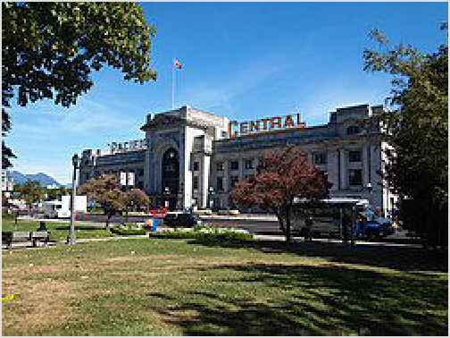See also: Rail travel in Canada

Pacific Central Station
Taking the train to Vancouver is unlikely to be the cheapest option, but it is a scenic one. Train stations:

- Pacific Central Station (https://www.viarail.ca/e n/explore-our-destinations/stations/rockies-and-p acific/vancouver), 1150 Station Street (one block north-east of Main St-Science World station on SkyTrain's Expo Line). Most trains and many intercity bus routes to the Vancouver area stop at this station. It is also a short taxi ride into the central business area. (updated Mar 2022 | ) Train options include:
Amtrak (https://www.amtrak.com/), ☏ +1 215-
856-7924, toll-free: +1-800-872-7245. Operates trains across the United States. (updated Mar 2022 | )
Amtrak Cascades operates between Vancouver, BC and Eugene via Bellingham, Mount Vernon, Everett, Edmonds, Seattle, Tukwila, Tacoma, Lacey (Olympia), Centralia, Kelso (Longview), Vancouver, WA, Portland, Oregon City, Salem, and Albany. Travel time to Vancouver, BC from Portland is 8 hours, from Tacoma is 5.5

hours, from Seattle is 4 hours, and from Bellingham is 2 hours. There is one round trip daily between Vancouver and Portland, and one round trip between Vancouver and Seattle. Over the whole route, there are two round trips daily along the portion between Vancouver and Seattle, four round trips daily along the portion between Seattle and Portland, and two round trips daily along the portion between Portland and Eugene. No train departures travel the whole length of the route. Additional service between Vancouver and Seattle, and between Portland to Eugene are provided on the Amtrak Thruway Motorcoach. Connections to additional Amtrak trains are in Seattle. When traveling on the Amtrak Cascades, border control takes place at Pacific Central station both for departing travelers to the United States and arriving passengers from the United States.
VIA Rail Canada (https://www.viarail.ca/), toll-free: +1-888-842-7245. Operates train routes across Canada. (updated Mar 2022 | )
Operates The Canadian up to three trips per week between Toronto and Vancouver with stops in both directions in medium to large cities and tourist destinations such as Sudbury, Winnipeg, Portage la Prairie, Saskatoon, Edmonton, Jasper, and Kamloops. This route can offer a scenic view of the Canadian Rockies, depending on the train schedule, as the train operates day and night. Travel time to Vancouver from Toronto is 4 days 1.25 hours, from Sudbury is 3 days 18 hours, from Winnipeg is 2 days 10.5 hours, from Saskatoon is 1 day 22.25 hours, from Edmonton is 1 day 9 hours, from Jasper 23.5 hours, and from Kamloops is 11 hours. This service connects with another route that travels between Jasper and Prince Rupert.
- Waterfront station, 601 West Cordova Street (Served by the Skytrain). Serves West Coast Express commuter trains from Mission. Trains only run during rush hour in the peak direction. (updated Jan 2025 | )
- Rocky Mountaineer station, 1755 Cottrell St (from Pacific Central Station, head east on Terminal Ave and south on Cottrell St). Located 1.5 km east of Pacific Central Station. The nearest public transit is 800 m away on Clark Drive. (updated Mar 2022 | )
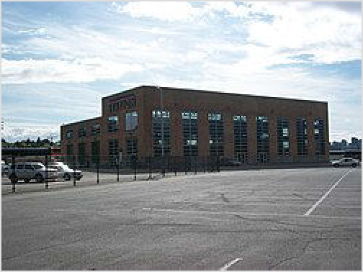Rocky Mountaineer (https://www.rockymounta ineer.com/), toll-free: +1-877-460-3200.
Operates the Rocky Mountaineer luxury tourist train routes between Vancouver and Banff, Lake Louise and Jasper three times a week from April to October. This route offers a scenic view of the Canadian Rockies and only operates during the daytime, with an overnight stop in
Kamloops. (updated Mar 2022 | )

By boat

By ferry
Rocky Mountaineer station in Vancouver

BC Ferries (https://www.bcferries.com/), toll-free: +1-888-223-3779. Operates ferry routes connecting coastal communities in British Columbia. The ferries carry vehicles and passengers. (updated Mar 2022 | ) To reach the Vancouver area from other coastal communities, travellers need to reach either of the following ferry terminals:
- Vancouver (Horseshoe Bay) (https://www.bcferries.com/travel-boarding/terminal
-directions-parking-food/vancouver-horseshoe-bay/HSB), in West Vancouver. Ferries travel between this terminal, and Bowen Island (Snug Cove) in 20 minutes, Nanaimo (Departure Bay) in 1 hour 40 minutes, and the Sunshine Coast (Langdale) in 40 minutes. See West Vancouver for more information.

- Vancouver (Tsawwassen) (https://www.bcferries.com/travel-boarding/terminal-di rections-parking-food/vancouver-tsawwassen/TSA), in south Delta. Ferries travel between this terminal and Nanaimo (Duke Point) in 2 hours and Victoria (Swartz Bay) near Sidney on Vancouver Island in 1 hour 35 minutes. Ferries also connect this terminal with five of the Southern Gulf Islands. See Delta for more information.

- Hullo (https://hullo.com/), 28 - 1055 Canada Place. Operates daily passenger only ferry trips between Nanaimo and downtown Vancouver, taking 1.25 hours each way. A single
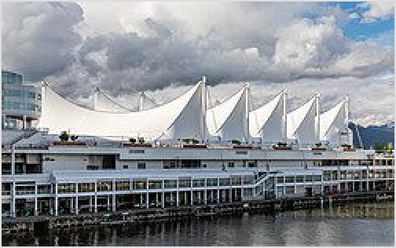carry-on-sized bag and a personal bag are permitted with passengers, and otherwise there is an additional charge per bag. Compared to BC Ferries, Hullo has the advantages of the trip to or from Vancouver being faster and that there will be WiFi on board, but the least expensive fare on Hullo is more than double the fare to travel on BC Ferries. The nearest public transit to Hullo's Vancouver ferry terminal is about 400 metres away and there is public transit that stops at Hullo's Nanaimo ferry terminal. (updated Feb 2024 | )

Canada Place

By cruise ship
Port Metro Vancouver (https://www.portvancouver.co m/) is the home port for the popular Vancouver-Alaska cruise. From late April to early October, more than 3/4 million visitors pass through the cruise ship terminal in Port Metro Vancouver.

- Canada Place Terminal (https://www.canadap lace.ca/) (One block west and one block north of Waterfront station on SkyTrain's Expo and Canada Lines.). It's on the waterfront and a few minutes' walk to the heart of downtown Vancouver or Waterfront Station. It is the primary cruise ship terminal. Canada Place was built for Expo86 and is recognized by its dramatic rooftop that looks like five white sails. A full range of ground transportation, excellent hotels, shopping, dining, entertainment, and attractions is available at Canada Place. (updated Mar 2022 | )

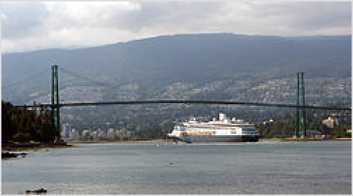A cruise ship passing under Lions Gate Bridge

US passport holders may be able to participate in
"Onboard Check-in” and “US Direct" to streamline processing at the cruise ship and the airport. US Direct allows passengers arriving at Vancouver International Airport (YVR) to transfer directly to a same-day-departing cruise ship by participating in expedited immigration and customs clearance process. Onboard Check-in allows passengers arriving on a cruise ship and flying out of YVR on the same day to transfer directly to YVR by participating in an expedited immigration and customs clearance process.
These programs do not apply to passengers who are planning a pre- or post-cruise stay in Vancouver. Not all cruise lines participate, so check with your cruise line to see if you can take advantage of the Onboard Check-in/US Direct program.

Get around

Vancouver is one of the few major cities in North America without a freeway leading directly into the downtown core (freeway proposals in the 1960s and 1970s were defeated by community opposition). As a result, development has taken a different course than in most other major North American cities resulting in a relatively high use of transit and cycling, a dense, walkable core and a development model that is studied and emulated elsewhere.

By public transit
TransLink (https://www.translink.ca/), ☏ +1-604-953-3333. The main public transit network in the Vancouver area, including: Bowen Island, Burnaby, Coquitlam, Delta, Langley, Lions Bay, Maple Ridge, New Westminster, North Vancouver, Port Coquitlam, Pitt Meadows, Port Moody, Richmond, Surrey, Vancouver, West Vancouver, and White Rock. Its network includes buses, SkyTrain (rail rapid transit), SeaBus (ferries), West Coast Express (commuter rail), and HandyDART (door-to-door shared-ride service for those who cannot ride public transit without assistance). (updated Mar 2022 | )

TransLink's (https://www.translink.ca) website and customer information line both offer trip planning and information about fares, where to buy tickets and the refund policy. A regional transportation map is widely available at convenience stores and on TransLink’s website. TransLink does not have a mobile app, but Google Maps (https://www.google.com/maps), Transit (https://transitapp.com/region/vancouver) and Citymapper (https://citymapper.com/v ancouver?set_region=ca-vancouver) all have access to TransLink's GPS data to show current route information and estimated arrival times.

Fares and zones
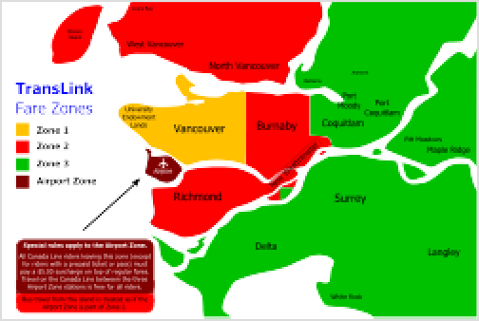TransLink breaks Metro Vancouver into three fare zones; your fare depends on the number of zones you travel in. The standard adult fare is $3.35 for all bus trips across Metro Vancouver and SkyTrain travel within the City of Vancouver (Zone 1). It also covers all travel system-wide at off-peak times: weekends, holidays, and weekday evenings after 6:30PM. Travel out of Vancouver on the SkyTrain or SeaBus crosses fare zone boundaries and costs $4.85 to $6.60 on weekdays before 6:30PM.

TransLink fare zone map
After paying fare, you can transfer or re-board an
unlimited number of times at no extra charge for 90 minutes. Compass Card and Compass Ticket users have no restrictions on transferring between modes of transit, but bus riders paying cash fare can only transfer to other buses.

Contactless credit and debit cards can be used directly at ticket gates, eliminating the need to buy a separate ticket.

Upon final tap-in within the 90-minute window, Compass Card and Compass Ticket users have an additional 120 minutes to tap out at their final destination. Tapping out after this time will result in another fare being charged.

Standard transit fares for the City of Vancouver (July 2025)

Number of Zones | What it covers | Adult Fare | Concession Fare
1 Zone | Travel within the city of Vancouver | $3.35 | $2.25
2 Zones | Travel between Vancouver and North Vancouver, West Vancouver, Burnaby, New Westminster and Richmond | $4.85 | $3.30
3 Zones | Travel between Vancouver and all other destinations | $6.60 | $4.50

Fares paid using Compass Card (see next section) are discounted and cost between $2.70 and
$5.10 for an adult fare.

Concession fares are available for youth (13-18) and seniors (65+), with ID. Children age 12 or younger are free.

Paying for your fare: Compass
The Compass Card
TransLink's Compass Card is a reusable smart card for paying fare electronically on all buses, the SkyTrain, the SeaBus, and the West Coast Express.

Riders using the Compass Card pay the discounted FareSaver fare on each trip, with unlimited free transfers and re-boarding for 90 minutes after the first tap-in. Fare is deducted from the card's stored value. Compass Cards can also carry daily and monthly passes.

Tap in at the start of every trip on any vehicle, and tap out every time you exit through a fare gate. Bus riders do not tap out. Doing this lets the system calculate the right fare.

Get more information about the Compass Card
CompassCard.ca online (http
Compass (https://www.translink.ca/transit-far es/compass-card) is the electronic fare system for buses, SkyTrain, SeaBus and the West Coast Express. Buses still accept cash when you board, but fare gates at SkyTrain and SeaBus station only accept Compass. There are two Compass choices:

Compass Ticket — A white ticket that is good for one trip. The DayPass – unlimited travel on bus, SkyTrain and SeaBus across all zones for one day
– can also be purchased as a Compass Ticket; and
Compass Card — A reusable smart card that can store value, load passes and offers discounted fares. Blue cards are for adult fares, orange cards are for concession fares. See the infobox for more information.
Compass Tickets and Adult Compass Cards can be purchased from the Compass Vending Machines in SkyTrain and SeaBus stations and some London Drugs locations. All types of cards and tickets may be purchased over the counter at some 7-Eleven, Safeway, London Drugs, Shoppers Drug Mart locations, and the TransLink Customer Service Centre at Waterfront station. TransLink's website has a handy map (https:// www.translink.ca/transit-fares/where-to-buy) showing the locations of Compass retailers and Compass
Vending Machines. The vending machines accept cash,
Interac debit cards, and Visa or MasterCard credit card. American Express can only be used to buy a card or ticket from a retail location.

The purchase of a Compass Card requires a $6 deposit. The deposit is refundable if you return your Compass Card to or mail a Refund Request form to the Compass Customer Service Centre, but if your remaining cash balance is above $20, the only way to get back the balance is to have a cheque mailed out, so make sure to use up your balance before you do so.
s://www.compasscard.ca).

Riders without Compass Cards can buy single-use Compass Tickets instead for the SkyTrain or SeaBus. Contactless American Express, Mastercard, and Visa credit cards, and contactless Interac debit cards (along with mobile payments software) can also be used at Compass readers to pay for a ticket. Buses still accept cash fare, but bus transfers purchased with cash cannot be used on the SkyTrain or SeaBus.

Tap in with your Compass Card or Ticket at the start of every trip on any vehicle, and tap out every time you exit through a fare gate. Bus riders do not tap out. Doing this lets the system calculate the right fare.

If you're travelling in a group, Compass Tickets and Cards cannot be shared between group members. Each person will need their own ticket or card to tap in and out of the fare gates.

Mastercard and Visa credit cards can also be used at Compass readers/fare gates for an adult fare. When you
tap-in, your card will be pre-authorized for a three zone fare. When you tap-out, the fare will be calculated according to the zones travelled. Mobile wallets (such as Apple Pay and Google Pay) also work, just make sure your phone will have enough battery so you can tap-out at the end of your journey. Debit cards still work at Compass vending machines, but not at Compass readers.

Find out how to pay fares and where to buy passes and TransLink's refund policy (https://www.t ranslink.ca/transit-fares/compass-card).

Passes and stored value
If you are going to make heavy use of the transit system, passes can be loaded onto a Compass Card.

A DayPass is a money-saving option for travellers who will use public transit heavily for one day. For $11.95 (or $9.40 concession) (July 2025), it offers unlimited travel across Metro Vancouver on bus, SkyTrain and SeaBus until the end of the service day, late at night.
Monthly passes can save you money if you will be using transit almost daily for a month. They cost between $111.60 and $201.55 (or $63.80 concession) depending on the number of zones.

Buses
The bus service covers the widest area and travels along most major streets in the city. Many of the routes within the City of Vancouver are electric trolley buses, powered by overhead wires.

A limited stop express bus line called the RapidBus serves, not only Vancouver, but the entire lower mainland (Metro Vancouver) RapidBus gets a priority lane in traffic, There are 6 different RapidBus Routes. When boarding the RapidBus, It's all door-boarding, and passengers must either tap in with their Compass Card or Compass Ticket, buy a ticket with cash, (exact change required, coins only), or present a ticket to the driver. To buy a ticket with cash, passengers must enter through the front door. The 6 RapidBus Routes are:

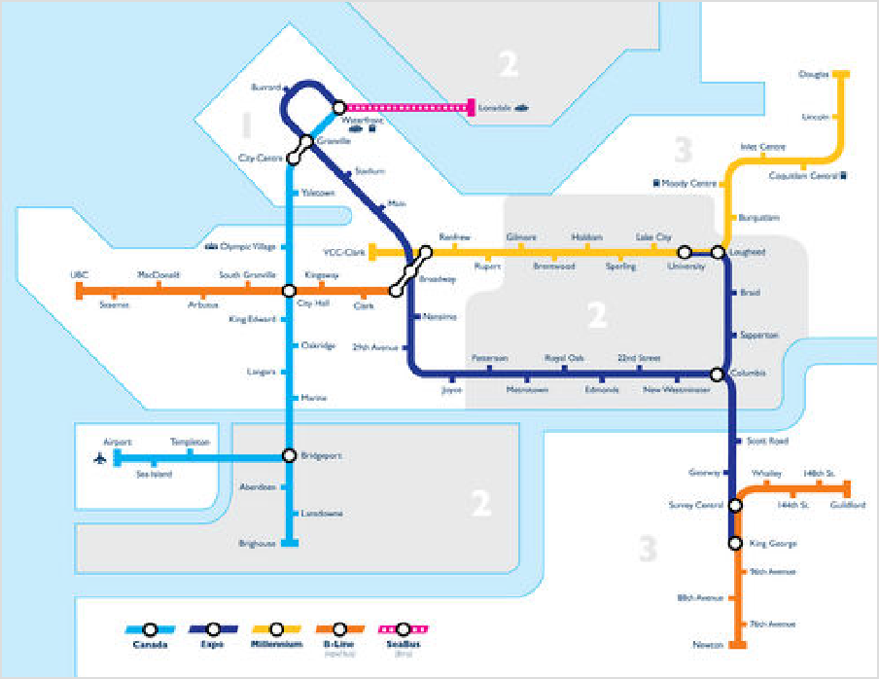R1 King George Blvd
Vancouver's rapid transit network
(operates in Surrey)
R2 Marine Drive (operates in North Vancouver and West Vancouver)
R3 Lougheed Highway (operates in Coquitlam, Port Coquitlam, Pitt Meadows, Maple Ridge)
R4 41st Ave (operates in Vancouver's UBC and South Vancouver areas)
R5 Hastings Street (operates in Vancouver's central business district, Gastown-Chinatown and East Van, and in Burnaby)

R6 Scott Road
(operates in Surrey)
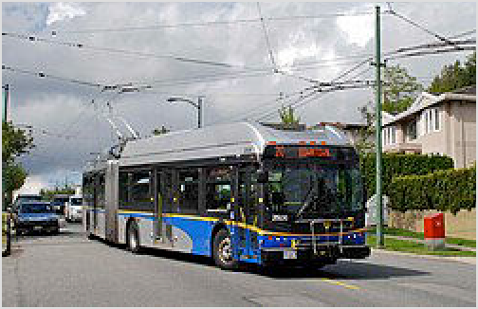Similar to RapidBus, is the

An electric trolley bus in Vancouver
99 B-Line, which is a limited stop express bus route that travels along Broadway Avenue (operates in Vancouver's UBC, Kitsilano, Mt Pleasant, and East Van). The portion of this route east of Arbutus St is to be replaced by an extension of the Millennium Line opening in 2027.
Cash fare on any bus to anywhere at any time is a flat
$3.35. Because of this, Compass Card users only tap in when boarding the bus, and never tap out when stepping off, unlike with all other modes of transit.

Every bus stop in Metro Vancouver has a unique five-digit bus stop number (the yellow number at the top of the bus stop sign). Send an SMS with that stop number to 33333 to get the next six scheduled bus arrival times. Standard text messaging rates apply. TransLink does not operate an app, but many third party apps (such as Google Maps) can be used to get transit times, additionally a mobile website is available. Many popular bus stops include a digital display with estimated bus arrival times. The stops for the RapidBus, have an electronic, real time, bus schedule.

SkyTrain
The SkyTrain is a mostly elevated, fully automated rapid transit system connecting downtown Vancouver with some of its suburbs to the south and east. Trains depart frequently throughout the day, on tracks separated from other traffic at up to 80 km/h.

The Expo Line runs from Waterfront Station in downtown Vancouver through Burnaby and New Westminster to Columbia Station, where it splits with some trips going to King George

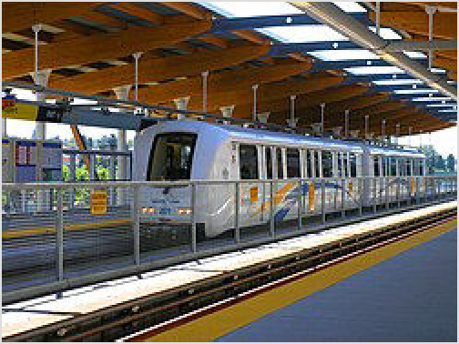Station in Surrey and the other track going to University/Production Way station in Burnaby. An eastern extension to Langley is expected to open in 2029.
The Millennium Line runs east-west from VCC-Clark in East Van through northern Burnaby to Lougheed Station, and then continues on to Port Moody and Coquitlam via the Evergreen Extension. A western extension along Broadway to Arbutus St is expected to open in 2027.
The Canada Line runs from Waterfront Station in downtown Vancouver south to Bridgeport Station, where it splits with some trips to Richmond's city centre and some trips to Vancouver International Airport's domestic and international terminals.
Key SkyTrain stations include:

The driverless SkyTrain at Rupert station

Commercial-Broadway – accesses restaurants and shopping on Commercial Drive in East Vancouver and transfer point to the 99 B-Line bus to UBC. Meeting point for the Expo Line and Millennium Line.
Burrard and Granville – the most central stations in the central business district. You can also connect to the R5 Hastings Street RapidBus route at Burrard station.
Waterfront – meeting point for Expo Line and Canada Line, the SeaBus, numerous commuter and rapid bus routes, and the commuter rail West Coast Express. It also accesses Gastown and is right next to the Canada Place Convention Centre/Cruise Ship Terminal facilities.
The fare on SkyTrain depends on how many zones you travel through and what time you're travelling. The City of Vancouver is Zone 1. Close-in suburbs like Burnaby, New Westminster, Richmond, and North Vancouver are Zone 2. Farther-out suburbs south of the Fraser River or east of Burnaby are Zone 3. At peak times, Compass Card users pay between $2.70 and $5.10, and riders paying cash fare pay $3.35 to $6.60 (all fares are standard adult fare). At off-peak times, passengers pay the one-zone.
Compass Card users tap in and out each time they pass through the fare gates. If you forget to tap in or out, you will be charged the maximum fare. People choosing not to use Compass Cards can buy single-use Compass Tickets instead.

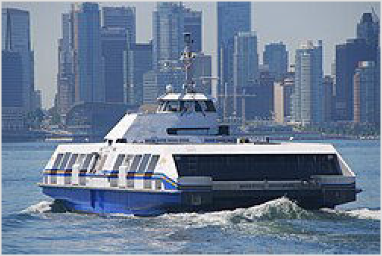SeaBus
SeaBus
The SeaBus is a passenger ferry that connects Waterfront Station downtown to Lonsdale Quay in North Vancouver. It generally runs every 15 minutes until the 9:16PM departure, after which it runs every 30 minutes until last sailing (M-Sa 1:22AM, Su 11:16PM).

During peak times, two-zone fare is required. That is
$4.00 for passengers with Compass Cards and $4.85 (July 2025) for those with Compass Tickets. At off-peak times, passengers pay one-zone fare.

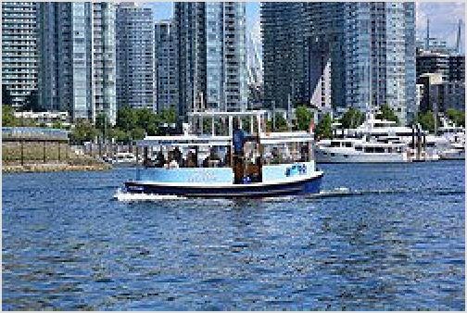By ferry

False Creek Ferries
Private operators have scheduled ferry service to destinations around False Creek. A quick trip across on a cute little-boat-that-could ferry can be the most fun, traffic-free, and convenient way to get around between the following destinations (from west to east):

Maritime Museum in Vanier Park on the south shore in Kitsilano (False Creek Ferries)
Aquatic Centre at Sunset Beach on the north shore in the West End (False Creek Ferries)
Hornby St on the north shore in the city centre (Aquabus)
Granville Island and its famous Public Market on the south shore (Aquabus / False Creek Ferries at different docks)
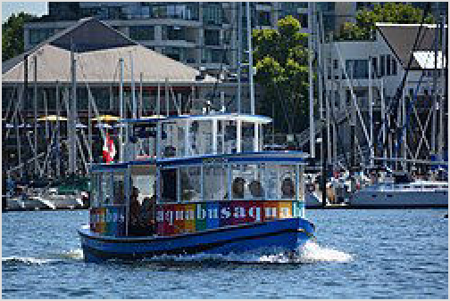Yaletown/Davie St. on the north shore (Aquabus / False Creek Ferries)
Aquabus
Stamp's Landing/Monk's and Spyglass Place on the south shore in the False Creek area (Aquabus / False Creek Ferries)
Plaza of Nations and Edgewater Casino on the north shore in Yaletown (Aquabus / False Creek Ferries)
Science World, the geodesic dome at the south-east end of False Creek (Aquabus / False Creek Ferries)
Service is offered by:

False Creek Ferries (https://granvilleislandferries.

bc.ca/), ☏ +1 604-684-7781. Little blue boats. (updated Jun 2023 | )
Aquabus (https://theaquabus.com/), ☏ +1 604-689-5858. Little rainbow boats. (updated Jun 2023 | )
The two ferries run slightly different routes, and their docks on Granville Island are on either side of the Public Market. As of Jan 2017, prices for adults are $3.25 for short routes, $5.50 for long routes, or $15 for a day pass. For seniors and children, the prices are $2, $3.75, and $11-13. Aquabus offers a 25-minute "mini-cruise" around False Creek for $8 per adult and $4 per child or senior.

By car
Vancouver's road network is generally a grid system with a "Street" running north-south and an "Avenue" running east-west. Arterial roads follow the grid fairly well (although not perfectly), but side streets frequently disappear for blocks at a time and then reappear. Most of the "Avenues" are numbered and they always use East or West to designate whether it is on the east side or the west side of Ontario Street. Some of the major avenues use names rather than numbers (Broadway would be 9th Ave, King Edward Ave would be 25th Ave).
Downtown Vancouver has its own grid system and doesn't follow the street/avenue format of the rest of the city. It is also surrounded by water on three sides, so most of the ways in and out require you to cross a bridge. This can cause traffic congestion, particularly at peak times (morning and evening commutes, sunny weekend afternoons, major sporting events), so factor that into any driving plans, or avoid if possible.

One of the best ways to avoid traffic congestion is to listen to traffic reports on AM730. This station reports only about traffic and can be quick to report any accidents and congestion, as well as B.C. ferry reports, bridge and tunnel updates, border wait times, and other information pertaining to getting around the city and its many suburbs. It also posts frequent weather updates and local news.
Go West... but which one?
The term frequently
Vancouver
"West" comes up
in connection with
and
can
be
confusing for locals and visitors alike. It can refer to:

the West Side of Vancouver, which is the area of Vancouver west of Ontario Street. It includes Kitsilano, South Granville, UBC and South Vancouver, but excludes the downtown peninsula,
the West End, which is the western portion of the downtown peninsula, and
West Vancouver, a municipality across the harbour in the North Shore.

A unique feature of Vancouver and the rest of British Columbia is intersections with flashing green traffic signals. These do not indicate an advance left turn as it would in many other parts of North America. Instead, a flashing green light indicates a traffic signal that can be activated only by a pedestrian or a cyclist on the side street, but not by a motor vehicle. When the signal turns red, traffic stops as at any traffic signal. Any side street traffic must obey the stop sign on the side street and must yield to any pedestrians crossing the side street, even if traffic is stopped on the main street.

Parking
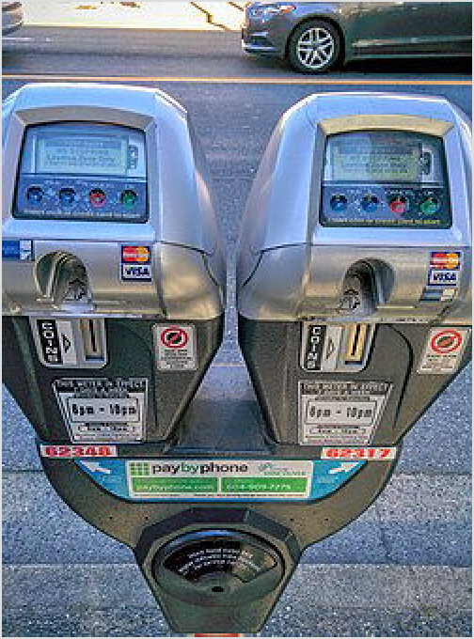Parking downtown generally costs $1-2.50/hour or $12- 20/day. Commercial areas will typically have meter parking on the street, with meters accepting Canadian and American change only (American coins accepted at par value). Residential streets may allow free parking, but some will require a permit. If you do not have cash with you, most meters allow you to text the lot and stall number to PayByPhone (https://paybyphone.com/), allowing payment through Visa or Mastercard. Each meter will specify if available.

Easy Park (https://www.easypark.ca/) lots (look for an orange circle with a big "P") rank as the most affordable of the parkades, but generally the cost of parking will not vary greatly among parkades within a certain area. Most will accept payment by credit card, as well as coins. Beware of scammers hanging around in some parkades, trying to sell parking tickets for less than their face value — typically, they have purchased the tickets with stolen credit cards. Also be careful parking overnight, as vehicle break-ins are not uncommon.

City meters and parking regulations are enforced regularly. Meter-related offenses will result in fines. Violations in private lots are generally unenforceable, but

Parking meters deployed by City of Vancouver that accept coins and credit card. Telephone payment is also accepted for pre-registered payment account. Rate vary depending on location and are stated on the top side, under the timer or on a screen at the top of the meter.

may result in your car being towed. If your vehicle is towed on a city street, you can recover it at the city impound lot at 425 Industrial Ave.

Some new meters at private parking lots throughout the city no longer accept cash, make sure to also have a credit card with you. Most parking facilities also accept payment using the PayByPhone (https://www.paybyphone.com) app.

Car sharing
Vancouver is often referred to as the car share capital, with over 2,000 available vehicles. Car sharing which allow vehicle rentals by the hour and minute. With the departure of Car2Go and Zipcar, the only companies left in this space are Evo (https://evo.ca/) and Modo (https://modo.c oop/). If you are a BCAA member, you can get a free Evo membership through their website. To sign up for Modo, if your licence was issued from outside BC, you will need to put down a $750 damage deposit or provide a copy of your driving records from your home country (including a translation to English made by an approved translator if it is not already in English.)

By taxi
Black Top Cabs (https://btccabs.ca/), ☏ +1 604-731-1111. (updated Jul 2022 | )
MacLures Cabs (https://www.maclurescabs.ca/), ☏ +1 604-831-1111. (updated Jul 2022 | ) Vancouver Taxi (https://www.vancouvertaxi.cab/), ☏ +1 604-871-1111. (updated Jul 2022 | ) Yellow Cab (https://www.yellowcabonline.com/), ☏ +1 604-681-1111. (updated Jul 2022 | )
Signature Black Car & Chauffeur Service (https://www.signaturecarservice.ca), ☏ +1- 778-927-1003. (updated Jan 2025 | )

By ride hailing
Apps legally permitted to operate in the Vancouver area include:

Kabu (https://www.kabu.ca/). (updated Jul 2022 | )
Lyft (https://www.lyft.com/rider/cities/vancouver-bc). (updated Jul 2022 | )
Uber (https://www.uber.com/global/en/cities/vancouver/). (updated Jul 2022 | )

By bicycle
Vancouver is a very bicycle-friendly city. In addition to the extremely popular seawall bicycle routes along Stanley Park, False Creek and Kitsilano, there is a network of bicycle routes that connect the whole city, with many of the downtown bike lanes separated from traffic. The City of Vancouver provides a map of the bicycle routes that is available at most bike shops or online. Also, all buses have bicycle racks on the front to help riders get to less accessible parts. North American visitors will find that drivers in Vancouver are more accustomed to sharing the road with cyclists than many places.

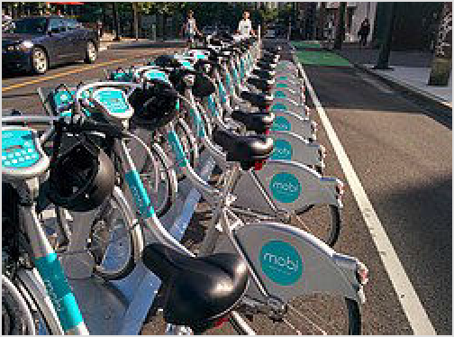Vancouver Mobi bike share near BC Place stadium in Downtown Vancouver

The city of Vancouver operates a bike share program called Mobi (https://www.mobibike s.ca/). A 24-hour pass costs $19 for an unlimited number of 30-minute trips, with each additional minute costing 25 cents. Monthly passes are available for $39 (30-minute trips). Trips on a monthly pass that take longer than the allowed time will be charged an extra 25 cents per minute. Bike stations are spread across downtown, the West End, Gastown, Yaletown and False Creek, Granville Island and Kitsilano. Bikes are unlocked via a user code and PIN that are provided after you complete registration on Mobi's website. It's highly recommended that visitors complete registration before their visit, as you cannot do it at bike share stations.

Longer term bike rentals are available at a number of independent shops, where you can rent bicycles by the hour, day or week. Many places also rent tandem bikes. Shops can be found in the central business district, the West End, Yaletown and near Granville Island. Alternatively, buy a used bicycle and either sell it on or donate it to someone in more need of it at the end of your stay.

By scooter
Renting a scooter is a good compromise between a bike and a car. Scooters are not allowed on the famous bike path, but it is possible to travel in the inner roads, park and walk at all the attractions. Average cost is ~$80 for 24 hours + gas.

Cycle BC (https://vancouver.cyclebc.ca/), Location 1: (next to harbour air terminal) Location 2: 73 East 6th Ave, ☏ +1 604-709-5663.
VanEcoRide (https://vanecoride.com/electric-scooter-rental-vancouver/) Escooter & Ebike Rental 1020 Mainland St unit 26 +1 778-683-7711
Vancouver Scooter Rental, 501-2050 Scotia St, ☏ +1 604-787-9177.

See

While Vancouver is still a young city, it has a variety of attractions and points of interest for the visitor.

Landmarks and historic buildings
Many of the city's landmarks and historical buildings can be found in the central business district. Canada Place, with its distinctive sails, the nearby Olympic Cauldron, the intricate Art Deco styling of the Marine Building and the old luxury railway hotel of the Hotel Vancouver are in the central business district. Stanley Park (the city's most popular attraction), along with its neighbouring Coal Harbour walkway and the Vancouver Aquarium are in the West End. Gastown, the original town site of Vancouver, has a number of restored buildings and its steam clock is a popular spot to visit. Modern architecture worth visiting also includes Shangri-La, the tallest building in the city, and the Sheraton Wall Centre, both located in central business district. Another popular city landmark, the bustling markets and shops of Granville Island, is just to the south of downtown in an area called South Granville.

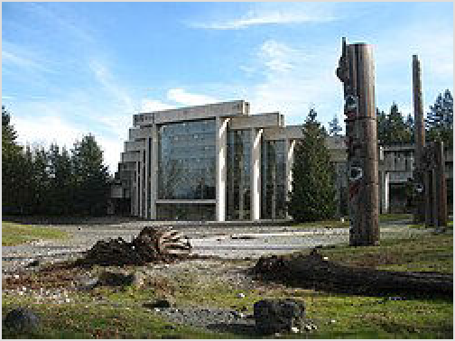Museums and galleries

Museum of Anthropology at UBC
If you're looking to learn about the people of the Northwest Coast and some of its history, one good spot is the impressive Museum of Anthropology at the University of British Columbia, which houses several thousand objects from BC's First Nations. The museum is also home to significant collections of archaeological objects and ethnographic materials from other parts of the world.

The Vancouver Art Gallery in the central business district combines local with international through a
variety of exhibitions and a permanent collection that focuses on renowned British Columbia
artist, Emily Carr.

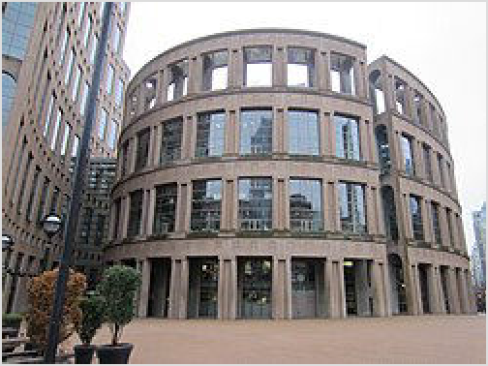The Central Library location of the Vancouver Public Library, in the central business district at Homer and Robson Streets, is modelled after the Roman Colosseum, and houses the city's largest library.

Another sight in the central business district is the small Contemporary Art Gallery on Nelson Street, which features modern art. Also nearby, on the east side of False Creek is the shiny geodesic dome of the Telus World of Science (commonly known as Science World), which has a number of exhibits, shows and galleries aimed at making science fun for kids.

Another great spot to check out is the BC Sports Hall

Central Library location of the Vancouver Public Library in the City Centre

of Fame and Museum at Gate A of BC Place Stadium in Yaletown. The BC Sports Hall of Fame and Museum preserves and honours BC's Sport heritage by recognizing extraordinary achievement in sport through using their collection and stories to inspire all people to pursue their dreams.

There are also some smaller sights in Kitsilano, including the Vancouver Maritime Museum, Museum of Vancouver, and H.R. Macmillan Space Centre.

Parks
The city has a wealth of parks and gardens scattered throughout. The most famous is Stanley Park at the tip of the West End. Its miles of trails for walking and cycling, beaches, magnificent views and the attractions (including totem poles) within the park gives it something for everyone. The most popular trail is the Seawall, a paved trail that runs around the perimeter of Stanley Park and now joins with the seawalls in Coal Harbour and Kitsilano, 22 km in length. The Vancouver Aquarium is in Stanley Park. Other

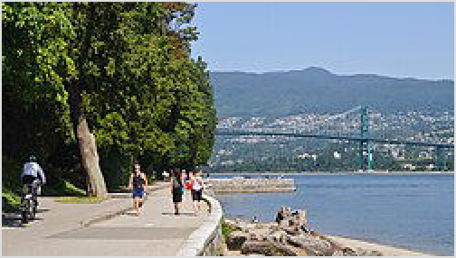A portion of the Seawall within Stanley Park with Lions Gate Bridge in the background

notable parks and gardens include VanDusen Botanical Garden in South Vancouver and Queen Elizabeth Park near South Main, the Nitobe Memorial Garden (commonly known as the Nitobe Japanese Garden) and UBC Botanical Garden at the University of British Columbia and the Dr. Sun Yat-Sen Classical Chinese Garden in Chinatown.

Admission to Vancouver's various attractions can range from $10 to up to $30 per person. There are a variety of attractions passes available that help visitors save on retail admissions such as the See Vancouver Smartvisit Card.

Nature
Finally, a trip to Vancouver wouldn't be complete without a glimpse of the skyline and the Coast Mountains rising above the city (clouds permitting, of course!). Popular spots to view it include Stanley Park in the West End, Harbour Centre in the central business district, Spanish Banks and Jericho Beaches in Point Grey, and Lonsdale Quay in North Vancouver. Other interesting views can be seen from City Hall at 12th and Cambie in Mt Pleasant, Queen Elizabeth Park in Mt Pleasant, and East Van's CRAB Park.

Do

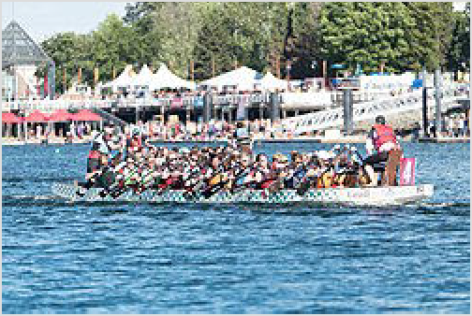Culture and festivals

Dragon Boating
Vancouver isn't all about the outdoors. It offers a variety of theatre, concerts and other cultural events. There are symphony and opera venues in the central business district and much of the city's live theatre can be found in South Granville, particularly on Granville Island with its thriving arts scene.
The city's Chinese heritage comes alive during Chinese New Year. Chinatown, in the east side of downtown, is
awash in colour and has many festivities, including a parade. June sees the annual Dragon
Boat Festival on False Creek.

There is no shortage of festivals around the city, with many local ones particular to a neighbourhood. The festival that draws the largest crowds is the Honda Celebration of Light (https://hondacelebrationoflight.com/), a three-night extravaganza of fireworks over English Bay in late July. Countries compete with 20-30 min displays choreographed to music. The fireworks start at 10PM and are best viewed from Sunset Beach in the West End or Kits Beach/Vanier Park in Kitsilano. It is strongly recommended to take public transit and to get there a few hours early as the crowds are huge. Roads in the vicinity of English Bay are typically closed from 6PM onwards.

EAT! Vancouver - The Everything Food + Cooking Festival takes place every year. The festival takes place in early November. Celebrity chefs, popular local restaurants, wineries, food & beverage manufacturers, cookbook authors, retailers, artisans, & many others from the culinary world come together for a 6-day event.

Other notable festivals include the Vancouver International Film Festival (https://www. viff.org) that runs in Sept-Oct; the Fringe Festival (https://www.vancouverfringe.com) that presents live theatre in a variety of styles and venues; Bard on the Beach Shakespeare Festival (https://bardonthebeach.org/) that runs May - September at Vanier Park in Kitsilano; and the three day Folk Fest (https://thefestival.bc.ca/) on the beach in Kitsilano that features a large selection of current and upcoming folk, roots and world music acts. Another notable event is Vancouver's annual Vancouver Pride Parade (https://vancouverpride.c a/), in early August, which attractsover 600,000 spectators.

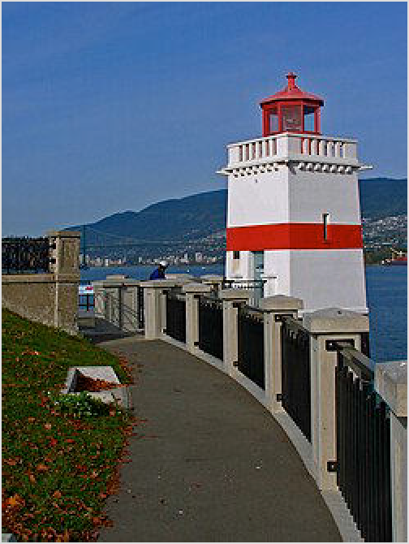Laugh
Vancouver is also home to an enormous stand-up comedy scene. With 3 dedicated clubs, and more than two dozen venues hosting regular events, the Lower Mainland plays host to nearly 10,000 improv, stand-up, and open mic shows a year, such as by the Improv Centre (https://theimprovcentre.ca/) on Granville Island. Catch touring comics, well-seasoned locals, or up and coming newbies at shows from theaters to pizza joints and experience some of the local, underground culture.

Live music
Vancouver has lots and lots of live music venues ranging from BC Place (over 60,000 seats) to local bars, pubs and coffee shops. There are also a plethora of festivals especially throughout the summer months. The Vancouver International Jazz Festival (https://ww

Views from the Seawall in Stanley Park

w.coastaljazz.ca/) runs for two weeks in late June and early July and attracts big name jazz and avant garde acts.

Outdoor activities
Vancouverites love the outdoors and one of the most popular things to do is to walk, jog, bike or rollerblade the Seawall. It starts at Canada Place downtown, wraps around Stanley Park and follows the shoreline of False Creek through Yaletown, Science World and Granville Island to Kits Beach in Kitsilano. The most popular sections are around Stanley Park and along the north shore of False Creek. Bike and rollerblade rentals are available from a few shops near the corner of Denman & West Georgia in the West End if you prefer wheeled transportation over walking. If the weather's nice, go out to Granville Island, rent a speedboat and take a boat ride on the waters around Stanley Park and Coal Harbour. Golf courses are also abundant in the city, along with more cost-conscious pitch-and-putt courses.
If you'd rather lie in the sun than play in the sun, Vancouver has a number of beaches. While certainly not glamorous and lacking waves, there's sand, water and lots of people on sunny summer days. Kitsilano has a string of beaches, the most well known being Kitsilano Beach, Jericho and Spanish Banks. Kits Beach is the most popular and has beach volleyball, Spanish Banks is a bit quieter and popular with skimboarders. There are a few beaches on the south and

west sides of downtown, with English Bay Beach (near Denman & Beach in the West End) being the largest and most popular. Finally, no discussion of Vancouver beaches would be complete without mention of Wreck Beach at the tip of Point Grey in UBC. As much rock as it is sand, it holds a place in the Vancouver identity and is the only city beach where you can bare it all. [2]

For many, Vancouver is synonymous with skiing and snowboarding. While there are no ski hills within the city itself, there are three "local" hills (Cypress, Grouse Mountain and Seymour) across the harbour on the North Shore. And of course, Vancouver is the gateway to Whistler, the biggest and one of the most highly rated snow destinations in North America.

Spectator sports
When you tire of doing stuff outdoors, or prefer that someone else do the hard work, you can always grab a seat and take in the local sports teams.

Hockey
The biggest draw in town is hockey (the variety played on ice, not a field) and the local professional team is the Vancouver Canucks (https://www.nhl.com/canu cks/). The team plays at Rogers Arena in Yaletown and the season lasts from October to April (and possibly longer when they make the play-offs). Tickets are pricey and the concessions are even worse, but it's a good game to watch live. The local junior hockey team, the Vancouver Giants (https://vancouvergiants.co m/), offer a cheaper but no less exciting experience, but

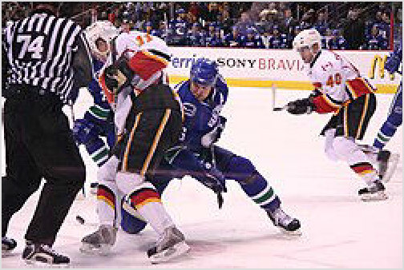Vancouver Canucks playing in their the blue uniform

play in the Langley Events Centre some distance from Vancouver.

Football
The BC Lions (https://www.bclions.com/), the city's Canadian Football League team (think American football with 12 players a side, three downs, a slightly larger field, and much larger end zones) plays during the summer and fall at BC Place in Yaletown.

Soccer
Welcome World Cup fans Vancouver is one of the 16 North American host cities for the 2026 FIFA World Cup, hosting soccer matches at BC Place Vancouver (BC Place), located in the downtown area near False Creek. Crowds can build quickly on big match days, so arriving early helps you find a good viewing spot.
Security checks are standard, and items like large bags may be restricted. There may be heightened traffic on match days.
The Vancouver Whitecaps FC (https://www.whit ecapsfc.com/), the third team to bear the "Whitecaps" name, began play in Major League Soccer in March 2011, becoming the second MLS team in Canada (they
have since been joined by a third Canadian team). They have played at BC Place since September 2011, when that venue reopened after post-Olympics renovations.
The Whitecaps initially planned to build a new stadium of their own near the waterfront, but local opposition led the Whitecaps to make BC Place their long-term home.

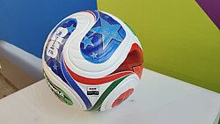Rugby
BC Place also hosts the Canada Sevens (https://can adasevens.com/), an annual event in the World Rugby Sevens Series (marketed as the HSBC SVNS (https://www.svns.com)), a worldwide series of tournaments for men's and women's national teams in rugby sevens, a variant of rugby union featuring 7
players per side instead of 15 (on the same full-size field) and halves of 7 minutes instead of 40. In the current schedule, the event is held on the last weekend of February as part of a North American swing that also includes an event in the Los Angeles suburb of Carson, California.

Roller derby
The Terminal City Rollergirls (https://tcrd.ca/) are Vancouver's first female roller derby league and are members of the Women's Flat Track Derby Association. Created in 2006, the league now has four full teams (Faster Pussycats, Bad Reputations, Public Frenemy, and Riot Girls) as well as an All-Stars team made up of the best players in the league. The players are a diverse group of women, from nurses to construction workers, graphic designers, television producers, teachers, stay-at-home moms, PhD students and aspiring rock stars. The bouts are exciting and fun (there is usually an entertaining half-time show). If you're thinking about attending a bout and know nothing or very little about flat track roller derby, check out the Women’s Flat Track Derby Association's (WFTDA) explanation (https://wftda.com/the-game/). Bouts are generally held April to September and at various arenas around Metro Vancouver, although the PNE Forum in East Van has been a popular venue.

Baseball
Vancouver has a single A baseball team, the Vancouver Canadians (https://www.milb.co m/vancouver), who play out of Nat Bailey Stadium in the Mt Pleasant area.

University sports
The two major universities in the Vancouver area both have comprehensive athletic programs, though not at the high profile of similar institutions south of the border:

Simon Fraser Red Leafs (https://athletics.sfu.ca). Represent Simon Fraser University in Burnaby. The Red Leafs sponsor teams in seven men's sports and nine women's sports.
Notably, SFU is the only Canadian school that's a member of the U.S. NCAA, though they are in Division II, competing with mostly smaller, regional U.S. institutions. SFU no longer plays football, either American or Canadian; it had played under American rules in the NCAA, but logistical complications led the school to drop the sport after the 2022 season. (updated Jun 2024 | )
UBC Thunderbirds (https://www.gothunderbirds.ca). Represent the University of British Columbia in the University Endowment Lands at the west edge of the Point Grey peninsula. The Thunderbirds field teams in 15 men's sports and 14 women's sports. Unlike SFU, UBC is a member of Canada's governing body for university sport, U Sports. (updated Aug 2022 | )

Tours
If you want to orient yourself in the city, there are a variety of tours – bus, walking, hop-on, hop- off – based out of the City Centre that will regale you with Vancouver lore while taking you to many of the main attractions.

Learn

Vancouver is a city with a rich assortment of educational institutions offering programs on nearly every possible occupation or avocation. There are two main universities (Simon Fraser University, and University of British Columbia). Polytechnic institutions offer degrees in addition to certificates and diplomas. Vancouver is also a popular destination to learn English: expect to see many learners from Asian countries, such as South Korea, and from Brazil.

Places of study within the city of Vancouver include:

The University of British Columbia (UBC) (https:// www.ubc.ca), is ranked as one of the world's 30 best universities and is the largest university in western Canada. It is publicly funded and has the highest student enrollment of any university in British Columbia. More than 50,000 full-time and part-time students in numerous disciplines are enrolled at the main campus in the UBC-Point Grey area. UBC also has a downtown campus in Vancouver at Robson Square in the city centre area. This location is geared more towards adult learning, business people and foreign students. Course calendars are readily available at Robson Square or on UBC's website.
Langara College (https://www.langara.bc.ca) is publicly funded and in South Vancouver. It offers a number of programs in the arts, humanities, business and technology, as well as continuing education and ESL classes.

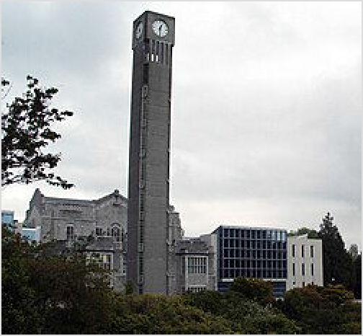Clock tower in the University of British Columbia

The Emily Carr Institute of Art + Design (https://www.ecuad.ca/) is publicly funded and in East Van. It offers a number of programs focused primarily on design and the visual arts.
The Centre for Digital Media (CDM) (https://thecdm.ca/) is publicly funded and in East Van. It is a collaborative university campus environment put together with the help of all of the major local universities, focusing on arts, technology, and the environment.
Vancouver Community College (VCC) (https://www.vcc.ca/) is publicly funded and has two campuses: Broadway in East Van, and downtown. VCC offers a number of different certificate and diploma programs.
University Canada West (https://www.ucanwest.ca/) is a private, for profit university that offers undergraduate and graduate business degrees.
The Vancouver Film School (https://vfs.edu/) is a private institution in downtown Vancouver.
Places of study in suburbs outside of the city of Vancouver include:

Simon Fraser University (SFU) (https://www.sfu.ca), is publicly funded and is the second highest enrollment of any university in British Columbia. With over 30 000 full-time students, SFU is consistently ranked as the best Comprehensive University in Canada by Macleans. Its main campus on the top of a mountain in Burnaby with spectacular views. SFU also has

the largest post-secondary presence in the city centre area, with the Beedie School of Business, the Morris J Wosk Centre for Dialogue (https://www.sfu.ca/dialogue.html), SFU Harbour Centre and SFU Woodwards, not to mention a satellite campus in Surrey.
The British Columbia Institute of Technology (BCIT) (https://www.bcit.ca), is publicly funded and a technical college based in Burnaby. It has a satellite campus in downtown Vancouver.
The Justice Institute of British Columbia (JIBC) (https://www.jibc.ca/) is publicly funded and is a post-secondary institution focusing on public safety vocations. Its main campus is in New Westminster.
Kwantlen Polytechnic University (KPU) (https://www.kpu.ca) is publicly funded with campuses in Richmond, Surrey, and Langley. It offers over 120 programs, including career, vocational trades and technology certificates, diplomas, and degrees across numerous disciplines.
Douglas College (https://www.douglascollege.ca/) is a publicly funded and offers degrees with campuses in New Westminster and Coquitlam.
Trinity Western University (TWU) (https://www.twu.ca/) is a private Christian university with undergraduate and graduate studies programs. Its main campus is in Langley and it has a smaller campus in Richmond.

Work

Traditionally, much of Vancouver's industry has centred around its port facilities and the forestry and mining sectors. Although these industries are still important to the economy, Vancouver's largest employers are now the various hospitals and educational institutions in the area and companies with head offices in Vancouver such as Telus Corp and the Jim Pattison Group. Vancouver however has expanded as a centre for software development and biotechnology, while streets provide a backdrop for an active film industry. Many jobs exist in the varied small and medium sized businesses that operate in the region. As with many cities, jobs are posted on-line or in the newspaper, but it helps if you have some contacts within the industry that can point you to the jobs that are open but not posted.
As with any tourist centre, there are a number of service jobs available. The attractions, restaurants and hotels downtown frequently need staff. Other areas to consider are Granville Island and the North Shore with its ski areas and Grouse Mountain.

Buy

This is only a sample of things you can look for in Vancouver. Visit the separate district pages for other info.

Tip - There are two local taxes that are charged on the vast majority of goods, the 7% PST (Provincial Sales Tax) and the 5% GST (Goods and Services Tax). The PST does not apply (https://www2.gov.bc.ca/gov/content/taxes/sales-taxes/pst/exemptions) to restaurants, motor fuel, food (including non-alcoholic drinks), vitamins, books, newspaper, magazines, bicycles, and children's clothing.

Robson Street (https://robsonstreet.ca/). In the City Centre is home to many touristy shops. The neighbouring Alberni intersection is also home to a variety of high-end shops such as Louis Vuitton and Hermès. (updated Aug 2022 | )

Pacific Centre (https://shops.cadillacfairview.com/property/cf-pacific-centre). Located in the City Centre. Has more than 150 shops, restaurants and services if you want to walk in an underground shopping centre. The shopping centre begins at its north end at Robson Street, and stretches all the way to Pender Street. There are many floors in the mall depending on where you are, and notable merchants include Holt Renfrew, Harry Rosen, Gap, H&M and Apple Store; the mall is connected to the Hudson's Bay (at Georgia and Granville streets), and Vancouver Centre (a small mall mainly consisting of a lotto centre, London Drugs, and a food court underneath Scotiabank). (updated Mar 2023 | )
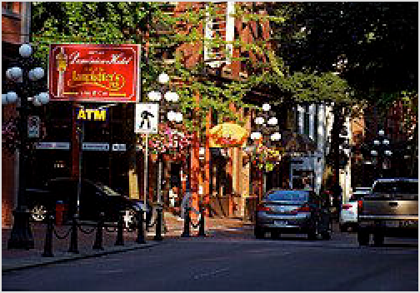Gastown. Is the oldest neighbourhood in Vancouver but is being reborn as a fashion and modern urban design district. Historic buildings house hip restaurants, galleries, and interior design and high- fashion shops. This area also is notable having the most tourist souvenir shops in the region. (updated Aug 2022 | )
Yaletown. Is also popular for its non-mainstream fashion boutiques and high-end salons. A few Popular Yaletown Shopping Streets are: Mainland

St., Hamilton St., and Pacific Blvd. (updated Oct 2023 | )
Granville Island. Is an interesting place to go if you fancy the arts. The area boasts a public market, an art school (Emily Carr University of Art + Design), shops, a world music instrument store, restaurants,
Gastown - the original townsite of
Vancouver and now the best place to find Vancouver kitsch

theatres, galleries, a hotel, boat docks and more. (updated Aug 2022 | )
Kerrisdale (http://www.kerrisdalevillage.com/) (Area centred on 41st, between Maple St and Blenheim St,). Located in South Vancouver. Consisting of roughly a hundred or so boutique-like shops, restaurants, and stores (chain or otherwise) in an affluent neighbourhood. (updated Aug 2022 | )
Commercial Drive (https://thedrive.ca/). Especially the stretch between 3rd Avenue and Venables St. in East Van, is great for people-watching, produce (Santa Barbara Market), cheese (La Grotta del Formaggio), sausage (JN&Z Deli), etc. (updated Aug 2022 | )
Main Street (South Main). Located in Mt Pleasant. South of Broadway stretching to around 30th Avenue, has a vibrant and expanding collection of independent restaurants, cafés, high- end niche clothing stores and small boutiques. (updated Oct 2023 | )
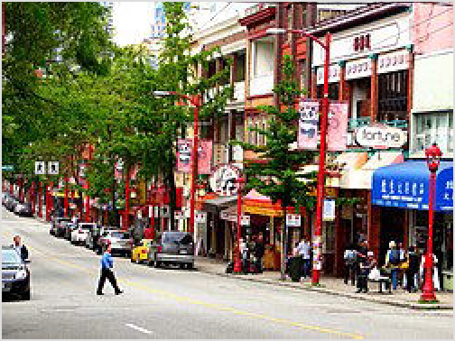East Hastings. Located in East Van between Renfrew and Clark offers some of the best hidden delights in the city. There are many eclectic produce stores (Donald's Market). (updated Oct 2023 | )

Vancouver's Chinatown
Chinatown (Around Main and Pender, and westwards down Pender from Main.). An old historic landmark where the first Chinese immigrants to the area settled, though these days it is a shadow of its former self, having become largely deserted and full of homeless people. Other newer and more vibrant Chinatowns have sprung up around 41st Ave. and Victoria Drive, also in Richmond and Surrey, and are much better places to go to if authentic Chinese culture and food is what you are after. (updated Aug 2022 | )
Punjabi Market. Around Main, between 41st and 49th Ave. Good, cheap Punjabi food along with some
Punjabi fashion; street signs are correspondingly in Punjabi. (updated Oct 2023 | )

There are some unique shopping areas in Kitsilano and East Van. In Kits you can visit the first store of Vancouver-born and based athletic retailer, Lululemon Athletica (https://shop.lululemo n.com/), sporting popular yoga-inspired apparel. Gore-tex jackets are ubiquitous in Vancouver and the best place to buy them is at Mountain Equipment Co-op (https://www.mec.ca/), Taiga Works (https://www.taigaworks.com/) or one of the other outdoorsy stores clustered together on the east-west main drag called Broadway (equivalent to 9th Avenue, running between 8th and 10th) between Cambie St. and Main St., just east of the Kitsilano area.

Eat

Where to begin? There is something for everyone in this cosmopolitan city, and the variety of cuisines and price points have been described as a foodie's delight. In particular, you will find many different kinds of Asian food available. If you fancy sushi many places offer "all you can eat" lunches for $12, which offers food of a wildly varying quality. In general, the city is up there with some of the best cities in North America when it comes to food. If you can do without alcohol, you can usually have a pretty reasonable meal for under $12, and at one of the more expensive restaurants in the city, $70 will get you a four course feast with exquisite service.

The highest density of restaurants is in Kitsilano or the West End. The central business area has many of the high end restaurants either along Robson Street or associated with the many hotels in the downtown area. East Van tends to have many authentic ethnic restaurants.

Vancouver is also famous for its Cantonese restaurants, in particular because it received a huge number of top chefs from Hong Kong fleeing the impending handover back to China in the 1980s and 1990s. Because of this large diaspora from Hong Kong, the price and quality of dim sum, siu mei and other Cantonese dishes here is among the best in the world, with many even claiming that Vancouver's Cantonese food is better than that of Hong Kong and Guangdong. However, Vancouver's Chinatown is now a shadow of its former self, with most of the remaining restaurants being tourist traps serving mediocre food. These days, the best Chinese food can be found in the suburb of Richmond, with a majority of its inhabitants being ethnically Chinese. Restaurants are all over the place on No. 3 Rd, Westminster Hwy, Alexandra Rd, and on the many side streets just east of Richmond Centre.

Vancouver has become a lot more vegetarian and vegan friendly. For exclusively veg-fare, there is Indigo Age downtown, the Naam in Kits, the Acorn on Main St, MeeT (Gastown, Main St, and Yaletown), Kokomo in Chinatown, Roots + Fruits in Strathcona, Eternal Abundance on the Drive, and Chomp in Hastings-Sunrise- to name only a few.

Many Vancouver restaurants recommend you have a reservation, the majority of them use OpenTable (https://www.opentable.com/vancouver-restaurants), or other similar software; however, some require you to phone. Check on the restaurants website or Yelp page before you go to be sure you will be seated in a timely manner.

For budget travellers, pick up a Georgia Straight (a free local paper available all over the place), and clip two-for-one coupons from the food section.
Every January, the city holds a food festival with over 270 local restaurants, which offer prix-fixe menus. The program, Dine Out Vancouver (https://www.dineoutvancouver.com/), runs over 17 days and includes the cities new eateries, neighbourhood favourites and award-winners. In 2017,

to will be held from January 20 to February 5.

Although the vast majority of stores around Vancouver accept credit cards, small family-owned Chinese businesses and restaurants, more often than not, accept only cash. Very few businesses in the city accept cheques.

Vancouver is also known for its gourmet ice cream shops, with some of the more notable chains including Rain or Shine Ice Cream (https://www.rainorshineicecream.com/), Earnest Ice Cream (https://earnesticecream.com/) and Bella Gelateria (https://ww w.bellagelateria.com/). While in Vancouver, make sure you try the "London fog" flavour, which is earl grey tea with fresh milk.

Food safety inspection reports are available online from the local health authority, Vancouver Coastal Health (https://www.vch.ca/en/service/restaurant-inspections-and-reports).

Drink

Most of the nightclubs are in the central business district, especially along the Granville Street strip, south of Robson and along Water Street in Gastown. There are a number of good local pubs in the various quieter neighbourhoods of the city, such as along Main Street or Broadway. Closing times for most of these pub-like establishments begin at 1AM; nightclubs close between 2AM-3AM with a very small number operating after-hours. Nightclubs with music, a DJ and a dance floor usually charge an entrance fee. Be aware that many nightclubs often have long lineup queues on weekends, which are usually self-imposed regardless of whether or not the establishment is near capacity to attract business. Flexibility and willingness to go early is key should nightlife become part of your travel plans.
Liquor stores by 11PM at the latest close, while many are closed by 9PM, and there will exist no other legal options apart from drinking at an establishment beyond this time.

Coffee
On Robson and Thurlow, there used to be two Starbucks kitty-corner to one another, hardly surprising as Starbucks is the most dominant of the three coffee shop chains found in Vancouver and it is claimed there are more Starbucks per capita in Vancouver than anywhere else. The other chains, Caffe Artigiano and Blenz, are found throughout downtown. JJ Bean is favoured among the locals and it's a great place to spend a few minutes to a few hours nursing a coffee and one of their ginormous muffins; there are ten locations scattered throughout the city. Bean Around the World is a popular coffee house chain with ten locations. Waves Coffee is popular with students for its 24-hour operations, and free Wi-Fi internet. For independent chains try Mario's on Dunsmuir and Howe; they have a unique feel and a slower pace than other coffee shops. Make sure not to miss Trees' cheesecakes and its roasted on-site organic coffees.
Vancouver has seen a rise of new independent coffee shops in the past three years, most of which focus on single-origin beans and a simpler approach to delicious coffee devoid of syrups and flavourings. Examples include: Matchstick (https://matchstickyvr.com/), Kafka's (http s://kafkascoffee.ca/), Revolver (https://revolvercoffee.ca/), 49th Parallel (https://4 9thcoffee.com/).

Tea
A distinctive local drink in Vancouver is called the London fog, which is similar to a latte except that it uses a shot of earl grey tea instead of espresso coffee. It is available at virtually every coffee shop in Vancouver.

Bubble tea (or boba tea) is also a popular drink among the Vancouver youth. There are countless tea houses throughout Vancouver, the most notable being Dragon Ball Tea House on West King Edward Ave and Oak St.

Beer
Vancouver offers a number of destinations for beer drinkers. The largest is the Granville Island Brewery on Granville Island (tours are available). Other microbreweries are housed in brewpubs, popular ones include the Yaletown Brewing Company in Yaletown and Steamworks at the entrance to Gastown. The Alibi Room, near Gastown, specializes in beers by Northwestern microbreweries as does the Cascade Room in South Main. Portland, also in South Main, is another craft beer venue that specializes in beers by Oregon based microbreweries.

East Vancouver, near Commercial Drive and E Hastings St, has become a hot spot for smaller craft breweries. This area is popular with locals who like to hit up a few different breweries, sampling beer and eating snacks like pepperoni sticks. There are over 10 breweries within walking distance of each other. Check out Storm Brewing, Callister Brewing, and Parallel 49 Brewing Company to name a few. $6 for a flight of 6 samples is standard, though some breweries such as Storm Brewing provide samples by donation. A pub with a great selection of craft beer is St. Augustine's near the Commercial/Broadway station.

Olympic Village, in False Creek, is another craft brewing hot spot, with multiple craft breweries within walking distance of eachother, including 33 Acres Brewing Company, Brassneck Brewery, Main Street Brewing Co, and more. All of these breweries are easily accessible by public transit.

If you fancy a short journey outside of Vancouver proper, Port Moody is easily accessible by Skytrain and has another great strip of small local breweries. North Vancouver, a 15 min SeaBus ride from downtown, offers another cluster of breweries, cider mill, distillery, winery, and braggotery along their newly developing "Brewery District".

Sleep

In general, accommodations in Vancouver are on the expensive side. Most upscale hotel rooms begin at $200-250/night, although you can find reasonably priced ones in the $100-180 range quite often. Most motel rooms cost somewhere between $80-150/night. If you are lucky to find hostel accommodation, the cheapest of these will cost around $30/night, more reasonably between $35-50.

The City Centre is centrally for attractions and has the bulk of Vancouver's accommodation, including most of the high-end hotels and backpackers hostels. If you don't mind getting away from the chain hotels, there are a number of smaller boutique hotels outside of the central

business district but still close to the action that are cheaper than the four and five star options downtown. Backpacker hostels are another cheap option with beds starting at $25 if you don't mind sharing a room.

Staying outside the City Centre area may give you a wider choice of affordable accommodations. There are a few budget hotels/motels along Kingsway in East Van and Broadway in South Granville. A number of B&Bs and AirBnB rentals are also scattered throughout the city in each district. If you want/need to stay close to the airport, Richmond has a number of hotels with varying degrees of luxury and price.

Finally, if you don't mind driving or commuting in to see Vancouver, the suburbs also have some cheaper options. North Vancouver, Burnaby and New Westminster all have easy access to Vancouver via the public transit system. The closest Provincial Parks with campgrounds are near Maple Ridge (Golden Ears Provincial Park), Chilliwack, and Squamish.

Camping in city parks is prohibited under Vancouver’s by-laws. Travellers may hear a claim that it is legal to camp overnight in city parks in Victoria and Abbotsford; (due to court cases that permit the homeless to do); but whether this would also apply to Vancouver or extend to travellers looking to free camp is unknown. That said, a small number of mostly homeless people do camp in city parks and it seems the bylaw is not always enforced. If you decide to do this, avoid the Downtown Eastside (Gastown-Chinatown and points directly east), don’t be disruptive, don’t light fires and be aware of the risks of free camping/sleeping rough.

Connect

In an emergency, dial 9-1-1 from any phone, even mobile phones with no service. If you're subscribed to Rogers for mobile service, or you're roaming on their network, they support 1-1-2 as well as 9-1-1. All other carriers only support 9-1-1.

The telephone area codes 604, 778, and 236 overlap Vancouver and the surrounding area. This means the Lower Mainland requires ten-digit dialing, so you must dial the area code when making a local call. Calls out of the region (east of Langley, or north of Squamish, including to Whistler) require a 1 before the area code.

At payphones, local calls cost a flat 50 cents each. Be aware that many public phones have been removed, especially in the suburbs, due to the rise of cell phones. Downtown payphones are often broken, but the payphones at the downtown SkyTrain stations are almost always in service. Payphones can be used to call 911 free of charge.

Free Wi-Fi is available at most hotels, cafés, and restaurants, as well as practically everywhere downtown. The city operates over 500 free Wi-Fi hotspots throughout the city. A full list of the city operated wireless hotspots can be found here (https://vancouver.ca/your-government/vanw ifi.aspx). Some Translink buses, skytrains, seabuses, as well as some stations and terminals also provide free Wi-Fi for transit passengers. Internet cafés are not as popular as they once were, but several remain in Vancouver, charging hourly with all-day passes available.

By mail
- Vancouver Main Post Office (https://www.canadapost.ca) (Canada Post), 495 W Georgia St (W George St & Richards St). (retail counter) M-F 9AM-6PM. Postcodes for the greater Vancouver area typically range from V5J through V6Z. There are also other postcodes in the surrounding cities making up the greater Vancouver metropolitan area ranging from V4A to V5J and from V7A to V7Y. Neighbourhood post office branches are within and operated by London Drugs, Shoppers Drug Mart, 7 Eleven and other retail stores contracted by Canada Post. They are marked with the red "Canada Post" signage and
logo. (updated Nov 2022 | )

Stay safe

Vancouver is a great place to visit if you use common sense like keeping an eye on your possessions, knowing where you are going and avoiding alleys and unfamiliar areas at night should keep you out of trouble. Unless involved in illegal activities (such as the drug trade), it is highly unlikely you will fall victim to any sort of violent crime. If you need emergency help, dial 911.

Like any major metropolitan city, Vancouver has areas that should be travelled with caution. The most notable is the Downtown Eastside (specifically Hastings Street between Abbott and Gore). This neighbourhood is infamous for homelessness, drug-use, and prostitution. As a result of these conditions, violence is quite a common problem. If you do accidentally stroll into the Downtown Eastside it is not difficult to find your way out, but if you get lost or feel uncomfortable the best thing to do is approach a police officer. Tourists exploring Gastown and Chinatown can easily wander into the Downtown Eastside unwittingly. Chinatown turns into a ghost town in the evening, and is mainly filled with homeless people, so you should avoid the area at night.
It's also wise to exercise caution in the Granville Mall area (Granville St between Smithe St and Hastings St) in the central business district on Friday and Saturday nights. As Vancouver’s bar and nightclub district, the sheer volume of people combined with alcohol consumption make disorderly conduct and rowdy behaviour fairly common. But this shouldn't act as a deterrent - if you're not looking for trouble, you probably won't find it, and there is a strong police presence. The streets at night in the Granville Mall area are usually (and quite literally) clogged with people at night time. Such an enormous mix of people and alcohol can be a dangerous mix if you are not cautious.

Some parts of the city have high rates of property crime. Theft from vehicles is especially problematic and parked cars with foreign or out-of-province plates are frequently targeted. The best thing is to not leave any money and valuables in plain view. Many of the locals use steering wheel locks to prevent vehicle theft.

While using public transit, if you feel unsafe, approach a Transit police officer (usually at SkyTrain stations). For non-emergency requests, you can call ☏ +1-604-515-8300.
Panhandling is common in some parts of downtown, but is unlikely to pose a problem. Don't be rude, as there may be negative consequences.

Drugs
Cannabis can be purchased from private dispensaries or the government-run BC Cannabis stores, which also offer online sales. It's legal for adults over 19 to consume and possess up to 30 grams of cannabis. It is not permitted to smoke or vape cannabis anywhere tobacco use is prohibited.

There are serious penalties for driving under the influence of THC, which include fines and vehicle seizure. Also, while Washington State has legalized recreational cannabis at the state level it remains illegal to bring any cannabis products over the border in either direction. Do not buy cannabis in Canada and attempt to take it into Washington State, or vice versa, not even at out of the way crossings like Point Roberts.

The province of British Columbia is the first jurisdiction in the world to decriminalize possession of hard drugs. Possession of up to 2.5 grams of cocaine (crack and powder), methamphetamine, MDMA, and opioids (including heroin, fentanyl and morphine) is no longer a criminal offence. In some areas such as Downtown Eastside, the government provides safe injection sites where you can safely dispose off needles after injecting yourself. The exemption is scheduled to last until Jan 31, 2026.

Driving while under the influence of drugs is a crime. Anyone caught selling drugs or trafficking them will still face criminal penalties. Possessing hard drugs at airports and many other locations remains illegal.

Cope

Publications
Vancouver Sun (https://vancouversun.com/). Vancouver's biggest daily newspaper. (updated Jul 2022 | )
The Province (https://theprovince.com/). Tabloid-style daily. A bit more sensational than the Sun and a better sports section, but published by the same company and
newsroom. (updated Jan 2017 | )
Georgia Straight (https://www.straight.com/). Free weekly paper that provides the best rundown on local bars and other entertainment listings. It also usually has a number of two for one coupons for local restaurants. (updated Jul 2022 | )
The Tyee (https://thetyee.ca/). Free daily online paper focusing on independent politics and culture reporting. (updated Jul 2022 | )
Vancouver Observer (https://www.vancouverobserver.com/). The Vancouver Observer is an independent online newspaper, covering local politics, arts, the environment, technology, health, nutrition, and other topics. (updated Jul 2022 | )
Vancouver Is Awesome (https://www.vancouverisawesome.com/). Free daily online paper focusing primarily on cultural events, food, and civic current affairs. (updated Jul 2022 | )
Other free weeklies include the Vancouver Courier, Westender, and Xtra West (gay and lesbian bi-weekly newspaper). Free dailies include 24 Hours and Metro.

Wireless
There are a number of wireless network providers in BC's lower mainland, all with store locations throughout Vancouver, including Telus (https://www.telus.com/)/Koodo (https://ww w.koodomobile.com), Rogers (https://www.rogers.com/)/Fido (https://www.fido.ca)/Chatr (htt ps://www.chatrwireless.com/), Bell (https://www.bell.ca/)/Virgin (https://www.virginmobile.c a/), and Freedom Mobile (https://www.freedommobile.ca). Another option is Public Mobile (htt ps://www.publicmobile.ca/en/bc), which operates mostly online only, but SIMs can be purchased at London Drugs and generally costs less than other providers. Many wireless carriers offer out of country travel plans; inquire with your carrier regarding pricing before your trip.

Religious services
Anglican (Episcopal): Christ Church Cathedral (https://www.thecathedral.ca/), 690 Burrard St, ☏ +1 604-682-3848. (updated Aug 2022 | )
Buddhist: Tilopa Kadampa Buddhist Centre (https://meditateinvancouver.org/), 1829 Victoria Diversion (Just south of 18th & Commercial in the Trout Lake neighborhood), ☏ +1 604-221-2271. Offers relaxation meditations and meditation classes to increase inner peace. (updated Aug 2022 | )
Muslim: Masjid Omar Al-Farooq (https://www.masjidomar.ca/), 1659 E 10th Ave, ☏ +1 604-873-2040, info@masjidomar.ca (mailto:info@masjidomar.ca). (updated Jan 2023 | )
Presbyterian: Central Presbyterian Church (https://www.centralpc.ca/), 1155 Thurlow St (Davie Village, near Davie and Thurlow), ☏ +1 604-683-1913. Sunday 10:30AM. (updated Aug 2022 | )
Protestant: St. Andrew Wesley United Church (https://standrewswesley.com/), 1022 Nelson St, ☏ +1 604-683-4574. (updated Aug 2022 | )
Roman Catholic: Holy Rosary Cathedral (https://www.holyrosarycathedral.org/), 646 Richards St, ☏ +1 604-682-6774. (updated Aug 2022 | )
Seventh-day Adventist: Oakridge Adventist Church (https://oacvancouver.ca/), 5350 Ballie St two blocks north of Oakridge Mall/Canada Line Station. Saturday 10AM and 11AM.
(updated Aug 2022 | )
Sikh: Akali Singh Sikh Society (https://akalisinghgurdwara.ca/), 1890 Skeena St, ☏ +1 604-254-2117. (updated Jan 2023 | )

Hospitals
- Vancouver General Hospital (VGH) (https://www.vch.ca/en/location/vancouver-gener al-hospital), 899 West 12th Ave (at the corner of Oak St and West 12th Ave), ☏ +1 604-875- 4111. VGH serves as the main hospital in Vancouver. Has an emergency department operating 24/7, serving people ages 17 and older. (updated Jan 2023 | )
- BC Children's Hospital (http://www.bcchildrens.ca/), 4500 Oak St (Oak St near King Edward Ave), ☏ +1 604-875-2345. Serves children up to 16 years old. Has an emergency department that operating 24/7. (updated Jan 2023 | )
- St. Paul's Hospital (https://www.providencehealthcare.org/hospitals-residences/st-pa ul%27s-hospital), 1081 Burrard St (downtown in the City Centre), ☏ +1 604-682-2344. St.
Paul's Hospital has an emergency ward operating 24/7 serving people of all ages, but is
smaller and therefore less equipped to handle many patients. Every winter, St. Paul's decorates the front of the Hospital with lights to encourage charitable donations. (updated Jan 2023 | )

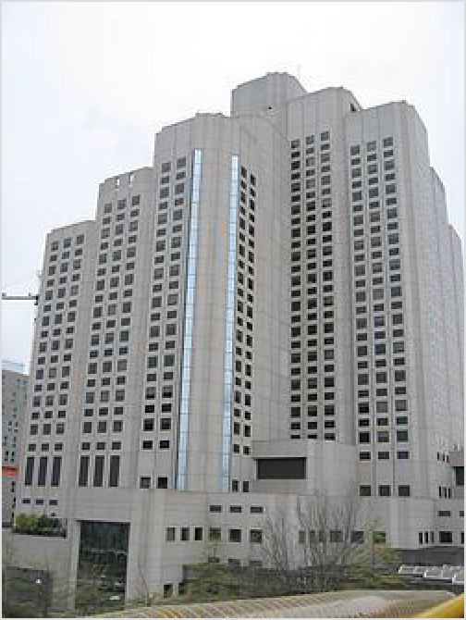Mount Saint Joseph Hospital (https://www.provi dencehealthcare.org/hospitals-residences/mount- saint-joseph-hospital), 3080 Prince Edward St, ☏
+1 604-874-1141. The only hospital on the city's East Side. Its emergency department operates daily 8:00 AM - 8:00 PM, serving people of all ages. (updated Jan
2023 | )
- UBC Hospital (https://www.vch.ca/en/location/u bc-hospital), 2211 Westbrook Mall, ☏ +1 604-822- 7121. The UBC Hospital emergency department operates daily 8 AM - 8 PM, to people of all
ages. (updated Jan 2023 | )
There are also a number of walk-in clinics around Vancouver. Unfortunately waits are usually around 30- 45 min for an appointment.

Consulates

Australia (https://canada.embassy.gov.au/),
1075 W Georgia St, Ste 2050, ☏ +1 604-684-1177,
fax: +1 604-684-1856. (updated Aug 2022 | )

One of Vancouver General Hospital's several buildings

8 Brazil (https://www.gov.br/mre/pt-br/consulado-vancouver), 666 Burrard St, Ste 2020, ☏ +1 604-696-5311, fax: +1 604-696-5366. (updated Aug 2022 | )
9 China (People's Republic of) (http://vancouver.china-consulate.gov.cn/), 3380 Granville St, ☏ +1 604-734-7492. (updated Aug 2022 | )
- France (https://vancouver.consulfrance.org/), 1130 W Pender St, Ste 1100, ☏ +1
604-637-5300. (updated Jul 2016 | )

Germany (https://canada.diplo.de/Vertretung/kanada/en/01/GK Vancouver/0-va
ncouver-hauptbereichsseite-eng.html), 999 Canada Pl, Ste 704, ☏ +1 604-684-8377, fax:
+1 604-684-8334. (updated Aug 2022 | )
- India (https://cgivancouver.gov.in/), 325 Howe St, Ste 201, ☏ +1 604-662-8811, fax:
+1 604-682-3556. (updated Aug 2022 | )
- Indonesia (https://kemlu.go.id/vancouver), 1630 Alberni Street, ☏ +1 604-682-
8855, congen@indonesiavancouver.org (mailto:congen@indonesiavancouver.org).
- Ireland (https://www.dfa.ie/irish-consulate/vancouver/), 1300-1095 West Pender St, ☏ +1 236-521-7300. (updated Aug 2022 | )
- Japan (https://www.vancouver.ca.emb-japan.go.jp/itprtop_en/index.html), 1177 W Hastings St, Ste 800, ☏ +1 604-684-5868. (updated Aug 2022 | )
- Korea (Republic of) (https://can-vancouver.mofa.go.kr/), 1090 W Georgia St, Ste 1600, ☏ +1 604-681-9581, fax: +1 604681-4864. 9AM-4:30PM. (updated Aug 2022 | )

Mexico (https://consulmex.sre.gob.mx/vancouver/index.php/es/), 1177 West
Hastings Street, Suite 411, ☏ +1 604-684-1859, fax: +1 604-684-2485. (updated Aug 2022 | )
- New Zealand (https://www.mfat.govt.nz/en/countries-and-regions/americas/cana da/new-zealand-high-commission/), 1050 W Pender St, Ste 2250, ☏ +1 604-684-7388, fax: +1 604-684-7333, vancouveroffice@nzte.govt.nz (mailto:vancouveroffice@nzte.govt.nz).
(updated Aug 2022 | )
19 Romania (https://vancouver.mae.ro/), Suite 855, 555 Burrard Street, Two Bentall Centre, V7X 1M8, ☏ +1 604 633 0757, vancouver@mae.ro (mailto:vancouver@mae.ro). General Consulate. (updated Aug 2022 | )

20 Switzerland (https://www.eda.admin.ch/vancouver), 999 Canada Pl, Ste 790, ☏ +1
604-684-2231, fax: +1 604-684-2806.
21 Taiwan (https://www.taiwanembassy.org/cayvr_en/index.html), 650 W Georgia St, Ste 2200, ☏ +1 604-689-4111. (updated Aug 2022 | )
- Thailand (http://www.thaiconsulatevancouver.ca), 1040 Burrard St, ☏ +1 604-687-
1143, fax: +1 604-687-4434.
- United Kingdom (https://www.gov.uk/world/canada), 1111 Melville St, Ste 800, ☏
+1 604-683-4421, fax: +1 604-681-0693. (updated Aug 2022 | )

United States (https://ca.usembassy.gov/u-s-consulate-vancouver/), 1075 W
Pender St, ☏ +1 604-685-4311, fax: +1 604-685-7175.

Go next

Nearby municipalities
There are a number of things to see and do just outside of Vancouver's borders. Some of the most popular are listed below. All of these places are accessible by public transit, or if you have a car, within an hour's drive.

North Vancouver - Take in the views from Grouse Mountain (The Peak of Vancouver), go for a walk on a suspension bridge or enjoy one of the many outdoor recreation opportunities -- hiking, mountain biking, skiing/snowboarding, kayaking -- on offer. The most popular summer activity in the area is hiking the 'Grouse Grind', a 2.9-km, 853-m elevation gain hike up the side of Grouse mountain.
West Vancouver - A municipality north of the Lion's gate bridge, en route to Whistler. Home to many beaches, coves, parks and expensive real estate, where breathtaking views of Vancouver can be scoped by driving its higher altitudes.
Burnaby - Shop till you drop at Metropolis at Metrotown, the largest shopping mall in British Columbia, or relax at one of the large regional parks. Also home to Simon Fraser University's main campus (notable for its brutalist architecture), on top of Burnaby mountain.
Port Coquitlam, Coquitlam and Port Moody (the Tri City area) - Half hour drive down Hastings street to the Barnet Highway will bring you to Port Moody, locally known as the City of the Arts.
Richmond - City with a large Asian influence with many options for Chinese, Japanese and Korean dining and shopping, one of the largest Buddhist temples in North America and the historic seaside Steveston towards the south offers a quieter, small-town type atmosphere.
Surrey/White Rock - A 45 minute drive away from Vancouver, famous for its moderate climate and sandy beaches. Surrey is also the place to go for South Asian shopping and watching Bollywood movies.
Fort Langley - Village with unique shops, restaurants and the site of one of the first forts built in British Columbia.
New Westminster - Small city on the banks of the Fraser River that was once the capital of British Columbia.
Delta - Made up of three communities separated by farmland; North Delta, Ladner, and Tsawwassen. Ladner has a quaint village-like atmosphere which has attracted several movies to be shot there and is the home of the George C. Reifel Migratory Bird Sanctuary (ht tps://www.reifelbirdsanctuary.com/). Tsawwassen has Boundary Bay Regional Park with its walking trails and bird watching opportunities.

Day trips
Bowen Island is a popular day trip or weekend excursion offering kayaking, hiking, shops, restaurants, and more. This authentic community is in Howe Sound just off Vancouver, and is accessed by ferry from Horseshoe Bay in West Vancouver.
For those who enjoy outdoor activities, a trek up the Sea to Sky corridor is essential. Squamish has branded itself the "Outdoor Recreation Capital of Canada" and with an incredible amount of quality rock climbing, mountain biking, white water rafting, hiking, kayaking, horseback riding, fishing, golf, walking trails and more, it certainly deserves the title. Squamish is about half way between Vancouver and Whistler. Whistler (1.5-hour drive from Vancouver) is expensive but well-known because of the 2010 Winter Olympics. In the winter, enjoy some of the best skiing in North America, and in the summer try some authentic mountain biking.
Another good spot for outdoor activities is Mount Baker across the border in Washington. Driving time is about three hours, but border line-ups can add anywhere from a few minutes to several hours onto your trip.
The nearby Fraser Valley has a number of parks and lakes that are nice for fishing, hiking or relaxing. A popular lake beach destination is in Harrison Hot Springs.
A geopolitical oddity: Point Roberts, a village that's part of the United States but can only be reached by land through Delta, BC.

Further afield
Vancouver Island is a good spot to move on to from Vancouver. Victoria, British Columbia's capital, is a relaxing place. Tofino is a pretty spot on the island's west coast, good for whale and storm watching and has some of Canada's best surf (if you can brave the cold water). The island is reached by ferry, seaplane and bus.
The Southern Gulf Islands are also a short ferry ride or float plane flight away. The Southern Gulf Islands are known for their artist communities, wineries, fromageries and farms. These islands also boast incredible opportunities for boating, kayaking, hiking, camping and wildlife viewing in the Gulf Islands National Park Reserve.
The Okanagan is a four to five hour drive east, with a large number of wineries, water activities in the summer and skiing in the winter.
The scenery of Banff, Banff National Park and the Rocky Mountains is a long day's drive (8-9 hours) east.
To the south, in the United States, Seattle is a two and a half hour drive and Portland is a five hour drive (excluding any border line-up).






Routes through Vancouver
END ←  END ← | W  N |  |  | E  S | → Mission (EB) / Abbotsford (WB) → Edmonton  → → Bellingham → Seattle
Nanaimo ← North Vancouver ← |  | W | E |  | → Burnaby → Hope
END ← |  | W | E |  | → Burnaby → Hope
Whistler ← West Vancouver ←  END ← |  | N  W | S  E |  | → Richmond → Seattle / Victoria via  → Port Moody → Mission

Retrieved from "https://en.wikivoyage.org/w/index.php?title=Vancouver&oldid=5287502"

